Name
Class
Date
1-1

Game: Matching Expressions
Variables and Expressions

This is a game for two players. Cut out the algebraic expressions from the top table, mix them up, and place them in a stack with the expressions face down. Then cut out the verbal expressions from the bottom table and arrange them face down on your desk in 4 rows and 5 columns.
Player 1 picks the top card from the algebraic expressions stack. He or she then turns over a card from the verbal expressions arrangement. If the algebraic expression matches the verbal expression, the player keeps both cards. If there is no match, then the player places the algebraic expression at the bottom of the stack and places the verbal expression in the same location as it originally was.
Players take turns trying to find correct matches. The player with the most matches wins. The key is to try to remember the locations of the verbal expressions.
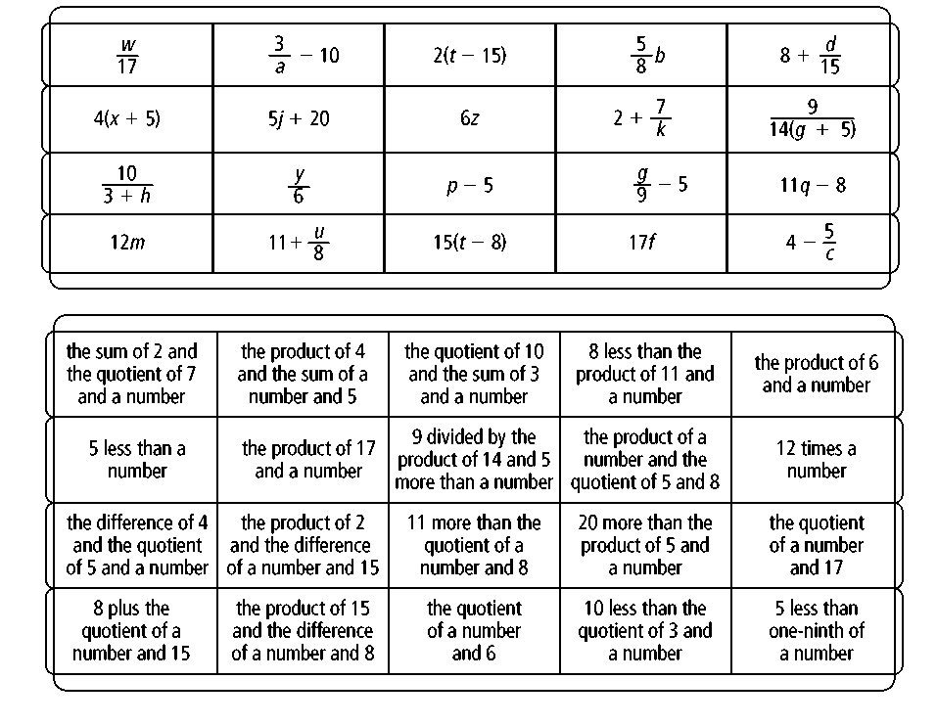
Prentice Hall Algebra 1 • Activities, Games, and Puzzles
Copyright © by Pearson Education, Inc., or its affiliates. All Rights Reserved.
1

