Name
Class
Date

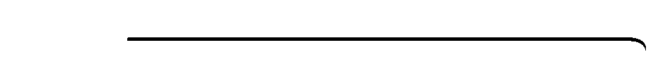
Game: Tic-Stack-Toe
3-1
Inequalities and Their Graphs
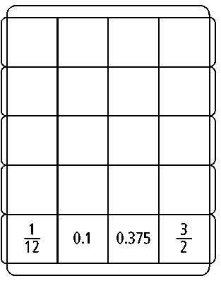
This game is for two players, X and Y. Players alternate turns. During your turn, roll a number cube twice. The first number is the numerator of a fraction. The second number is the denominator of the fraction. On the game board at the right, mark your letter with a pencil (X or Y) in a column labeled with a number less than the fraction that you rolled. The letter you mark must be at the bottom of a column or right above another letter, so letters are stacked up. The object of the game is to get three identical marks in a horizontal row, diagonal row, or a vertical column. As time permits, erase the game board and play again.

Example
Player 1 is Y and rolls a 3 and then a 6. The fraction is or .
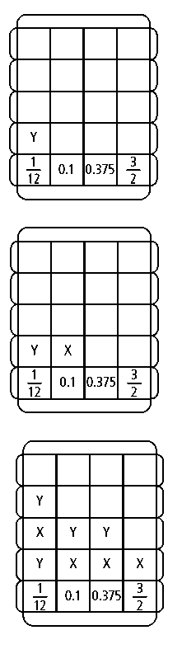
Player 1 can mark a Y at the bottom of the , 0.1, or 0.375 column, because these numbers are less than . Player 1 chooses to mark in the column.
Player 2 rolls a 5 and then a 3. The fraction is . Player 2 can mark an X in any column because all of the numbers are less than .
Player 2 chooses to mark in the 0.1 column.
As play continues, Player 1 marks the 0.1 column, Player 2 marks the column, Player 1 marks the column, Player 2 marks the 0.375 column, and Player 1 marks the 0.375 column. Then Player 2 rolls a 6 and a 3. Player 2 marks the column for the win.

Prentice Hall Algebra 1 • Activities, Games, and Puzzles
Copyright © by Pearson Education, Inc., or its affiliates. All Rights Reserved.
24

