Name
Class
Date


Puzzle: Inequalities With a Twist
3-7
Absolute Value Equations and Inequalities
Solve each inequality below in order. Round to the nearest hundredth if necessary. After solving an inequality, move to an adjacent square in the grid by identifying a number that is part of the solution. You may move either vertically or horizontally. Begin at the START. Mark your path as you solve each inequality to navigate your way to the EXIT.

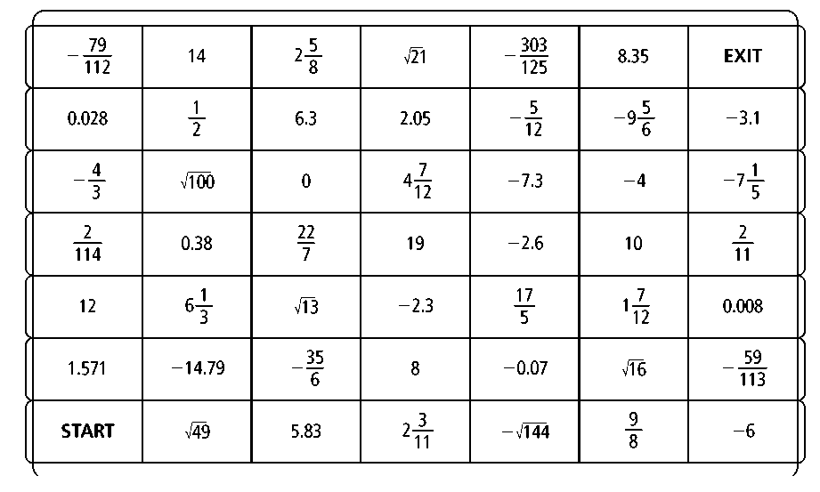
1. |3n +6|≤12 2. |14.2 –2.9 h|< 28.7 3. |2r – 1| < 9
4. |1 + 4y| < 3 5. 6.
7. 8. |0.25v + 1|< 375 9. |1.2 m–1.5| ≤ 4.5
10. |0.16b – 0.96| > 1.12 11.|2c –5| < 9 12. |3t + 1 | ≥ 8
13. 14. 15. |3.6x + 10.8|≤ 2.52
Prentice Hall Algebra 1 • Activities, Games, and Puzzles
Copyright © by Pearson Education, Inc., or its affiliates. All Rights Reserved.
31

