Line of Best Fit – Calculator Instructions

1. Lists into Calculator
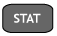1: Edit 

Enter x-values into L1
Enter y-values into L2

2. Turn Stat Plot on:
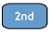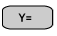1: Plot 1

Choose the following

3. Graph
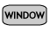Fill in min, max, and scales with appropriate values.
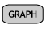

4. Calculate Line of Best Fit
Go to home screen 
Arrow over to CALC
Choose 4: LinReg(ax + b)

5. Graph Line of Best Fit
Go to Type Line of Best Fit from #4 in Y1 (must be in the form y = mx + b)

6. Calculate new value:
Go to graph screen
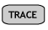
Choose 1: Value (type in your x-value)

