Name ______________________________________

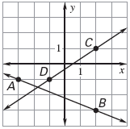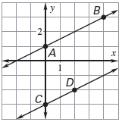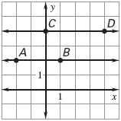1. 2. 3.

Slope of : _____ Slope of :_____ Slope of _____

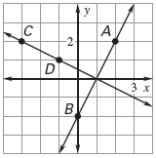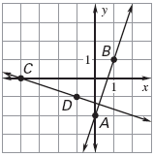 Slope of :____ Slope of :____ Slope of :_____

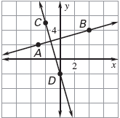

Slope of : _____ Slope of :_____ Slope of _____

Slope of :____ Slope of :____ Slope of :_____

What did you notice about the slope of parallel lines? ________________________________

What did you notice about the slopes of Perpendicular Lines? _________________________

Identify whether the pairs of equations are Parallel, Perpendicular, or neither.

7. Line 1: (-1, 2), (2, 3) 8. Line 1: (0, 1), (1, 3) 9. Line 1: (-5, 0), (-3, -2)

Line 2: (0, 0), (3, 1) Line 2: (4, -1), (5, 2) Line 2: (-2, 2), (0, 4)

Write an equation of the line that passes through the given point P and has the given slope *m*.

10. P (3, 4); *m*=4 11. P (6, -1); *m*= 12. P (-3, 2); *m*=

Write the equation of the line that passes through the point P and is **Parallel** to the line with the given equation.

13. P (3, -3);  14. P(-4, 6);  15. P (5, 3); 

Write the equation of the line that passes through the point P and is **perpendicular** to the line with the given equation.

16. P (-4, -4);  17. P (2, -3);  18. P (-4, -6); 