**PROPORTION RUMMY**

**What You Do:**

1. 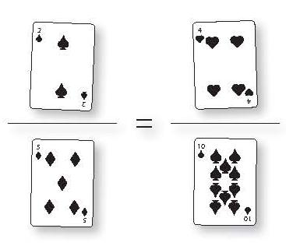Have each player draw two fraction bars with an equals sign between them on their papers.
2. Shuffle the deck. Deal four cards to every player in which they lay down on their paper. Place the remaining deck face down.
3. Each player will try to collect four cards that form a correct proportion. Keep in mind Aces = 1, Jacks = 11, Queens = 12, and Kings = 13.
4. On a player's turn, they must draw one card from the deck and discard one card from their hand that is on the table.
5. When a player has a proportion, they must say, "Proportion!" and each player checks to see if it is correct. If their answer is correct, they receive 1 point. Then they take 4 cards from the deck to refill their hand and play continues.
6. Play until the deck is empty and all possible proportions have been played.