Content: Math |  |  | Grade Level: 6th
Standard: 6.RP.3b

Use ratio and rate reasoning to solve real-world and mathematical problems, e.g., by reasoning about tables of equivalent ratios, tape diagrams, double number line diagrams, or equations.
I can statements:
- I can calculate unit rates.
- I can solve real world problems involving ratio and rate.
Score 4.0 | In addition to Score 3.0, in-depth inferences and applications that go beyond what was taught. |  | Sample Activities
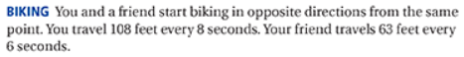
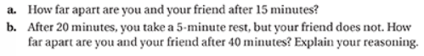
Solution: a. 4.09 miles b. 10.14 miles

 | 3.5 | In addition to score 3.0 performance, in-depth inferences and applications with partial success.
Score 3.0 | The student can solve real world problems using ratio and rate reasoning.  The student exhibits no major errors or omissions. |  | If steak costs $2.25 per pound, how much does 0.8 pounds of steak cost? Explain how you determined your answer.  Answer: The unit rate is $2.25 per pound so multiply $2.25 x 0.8 to get $1.80 per 0.8 lb. of steak.
 | 2.5 | No major errors or omissions regarding 2.0 content and partial knowledge of the 3.0 content.
Score 2.0 | There are no major errors or omissions regarding the simpler details and processes. However, the student exhibits major errors or omissions regarding the more complex ideas and processes.  The student can find simple unit rates. |  | Write a unit rate for the situation.  $28 saved in 4 weeks  Answer: $7 per 1 week
 | 1.5 | Partial knowledge of the 2.0 content, but major errors or omissions regarding the 3.0 content.
Score 1.0 | With help, a partial understanding of some of the simpler details and processes and some of the more complex ideas and processes.
 | 0.5 | With help, a partial understanding of the 2.0 content, but not the 3.0 content.
Score 0.0 | Even with help, no understanding or skill demonstrated.

