Content: Math |  |  | Grade Level: 6th
Standard: 6.EE.2c
Evaluate expressions at specific values of their variables. Include expressions that arise from formulas used in real world problems. Perform arithmetic operations, including those involving whole-number exponents, in the conventional order when there are no parentheses to specify a particular order (Order of Operations)
I can statements:
- I can simplify expressions when a value is given for a variable.
- I can use Order of Operations to simplify expressions that may include exponents.
Score 4.0 | In addition to Score 3.0, in-depth inferences and applications that go beyond what was taught. |  |  | Sample Activities
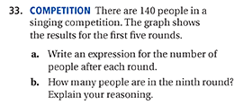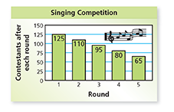
Answer: 20 people
 | 3.5 | In addition to score 3.0 performance, in-depth inferences and applications with partial success.
Score 3.0 | The student can solve multistep expressions involving properties of operations.  The student exhibits no major errors or omissions. |  |  | 4$²$ + (2x – 1) for x =5  Answer: 25  Your organization rents a bouncy house for an event. The company charges $45 to rent the house plus $30 for each hour of rental. Find the cost of 5 hours. ANSWER:$195
 | 2.5 | No major errors or omissions regarding 2.0 content and partial knowledge of the 3.0 content.
Score 2.0 | There are no major errors or omissions regarding the simpler details and processes. However, the student exhibits major errors or omissions regarding the more complex ideas and processes. |  |  | Evaluate 7n, where n=2  Answer: 14
 | 1.5 | Partial knowledge of the 2.0 content, but major errors or omissions regarding the 3.0 content.
Score 1.0 | With help, a partial understanding of some of the simpler details and processes and some of the more complex ideas and processes.
 | 0.5 | With help, a partial understanding of the 2.0 content, but not the 3.0 content.
Score 0.0 | Even with help, no understanding or skill demonstrated.

