Content: Math |  |  |  | Grade Level: 6th
Standard: 6.EE.9
Use variables to represent two quantities in a real-world problem that change in relationship to one another
I can statements:
- I can recognize that a change in the independent variable (x) creates a change in the dependent variable (y).
- I can evaluate the function (equation) for the values (input) given.
- I can compare the relationship between the independent (x) and dependent variable (y) using a graph (plotting ordered pairs).
- I can recognize which relationships between independent (x) and dependent (y) variables are linear.
Score 4.0 | In addition to Score 3.0, in-depth inferences and applications that go beyond what was taught. |  | Sample Activities
 |  |  | 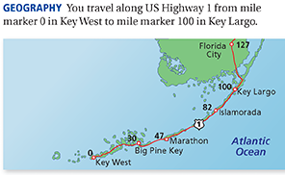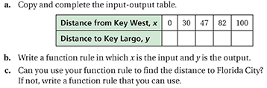
 | 3.5 | In addition to score 3.0 performance, in-depth inferences and applications with partial success.
Score 3.0 | The student can represent a real-world problem with function rules (equations), input/output tables, and graphs.  The student exhibits no major errors or omissions. |  | Sally earns $20 a week babysitting. Write an equation to represent the amount of money she will have after x number of weeks. Create an input/output table and graph to show the data.  Solution:  Input (x) 1 2 3 4  Output (y) 20 40 60 80  y=20x 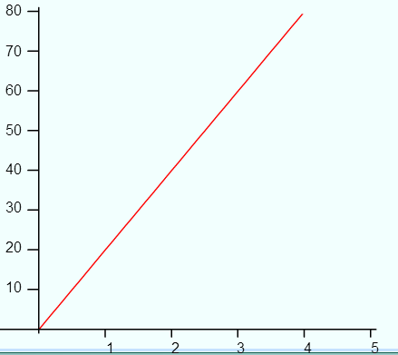
 | 2.5 | No major errors or omissions regarding 2.0 content and partial knowledge of the 3.0 content.
Score 2.0 | There are no major errors or omissions regarding the simpler details and processes. However, the student exhibits major errors or omissions regarding the more complex ideas and processes. The student can complete tables and graphs when given an equation. |  | 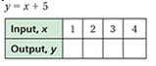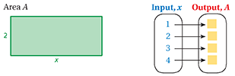
 | 1.5 | Partial knowledge of the 2.0 content, but major errors or omissions regarding the 3.0 content.
Score 1.0 | With help, a partial understanding of some of the simpler details and processes and some of the more complex ideas and processes.
 | 0.5 | With help, a partial understanding of the 2.0 content, but not the 3.0 content.
Score 0.0 | Even with help, no understanding or skill demonstrated.

