Content: Math |  |  | Grade Level: 6th
Standard: 6.NS.1
Interpret and compute quotients of fractions, and solve word problems involving division of fractions.
I can statements:
- I can interpret quotients of fractions.
- I can compute quotients of fractions.
- I can solve word problems involving division of fractions by fractions.
Score 4.0 | In addition to Score 3.0, in-depth inferences and applications that go beyond what was taught. |  |  | Sample Activities
 | 3.5 | In addition to score 3.0 performance, in-depth inferences and applications with partial success.
Score 3.0 | The student can solve real world and mathematical problems involving division of fractions, including those that involve mixed numbers.  The student exhibits no major errors or omissions. |  |  | 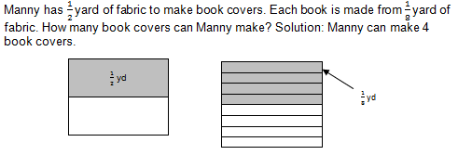
 | 2.5 | No major errors or omissions regarding 2.0 content and partial knowledge of the 3.0 content.
Score 2.0 | There are no major errors or omissions regarding the simpler details and processes. However, the student exhibits major errors or omissions regarding the more complex ideas and processes.  The student can solve problems involving basic division of proper fractions. |  |  | $$\frac{1}{8 }÷\frac{1}{4}$$  Solution: ½
 | 1.5 | Partial knowledge of the 2.0 content, but major errors or omissions regarding the 3.0 content.
Score 1.0 | With help, a partial understanding of some of the simpler details and processes and some of the more complex ideas and processes.
 | 0.5 | With help, a partial understanding of the 2.0 content, but not the 3.0 content.
Score 0.0 | Even with help, no understanding or skill demonstrated.

