Content: Math |  |  | Grade Level: 6th
Standard: 6.SP.5c
Summarize numerical data sets in relation to their context - e.g., giving quantitative measures of center (median and/or mean) and variability (interquartile range and/or mean absolute deviation), as well as describing any overall pattern and any striking deviations from the overall pattern with reference to the context in which the data was gathered.
I can statements:
- I can compute mean, median, and range.
- I can compute interquartile range.
- I can make a box-and-whisker plot for a set of data.
Score 4.0 | In addition to Score 3.0, in-depth inferences and applications that go beyond what was taught. |  | Sample Activities
Susan has four 20-point projects for math class.
Susan’s scores on the first 3 projects are shown below:
- Project 1: 18
- Project 2: 15
- Project 3: 16
- Project 4: ??
What does she need to make on Project 4 so that the average for the four projects is 17? Explain your reasoning.
 | 3.5 | In addition to score 3.0 performance, in-depth inferences and applications with partial success.
Score 3.0 | The student can solve multistep problems involving properties of operations.  The student exhibits no major errors or omissions. |  | 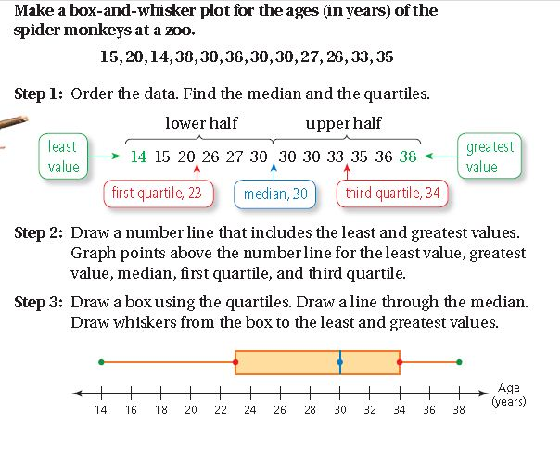  What is the outlier?  What measure does it affect the most?
 | 2.5 | No major errors or omissions regarding 2.0 content and partial knowledge of the 3.0 content.
Score 2.0 | There are no major errors or omissions regarding the simpler details and processes. However, the student exhibits major errors or omissions regarding the more complex ideas and processes. |  | Find the mean, median and range of the data:  11, 12, 12, 12, 12, 12, 13, 28  Answer: mean = 16, median = 12, range = 17
 | 1.5 | Partial knowledge of the 2.0 content, but major errors or omissions regarding the 3.0 content.
Score 1.0 | With help, a partial understanding of some of the simpler details and processes and some of the more complex ideas and processes.
 | 0.5 | With help, a partial understanding of the 2.0 content, but not the 3.0 content.
Score 0.0 | Even with help, no understanding or skill demonstrated.

