Content: Math |  |  |  | Grade Level: 6th
Standard: 6.G.1
Find the area of right triangles, other triangles, specific quadrilaterals, and polygons by composing into rectangles or decomposing into triangles and other shapes; apply these techniques in the context of solving real-world and mathematical problems.
I can statements:
- I can relate the area of triangles to the area of rectangles.
- I can visually and physically decompose and compose polygons into rectangles and triangles to determine area.
Score 4.0 | In addition to Score 3.0, in-depth inferences and applications that go beyond what was taught. |  | Sample Activities
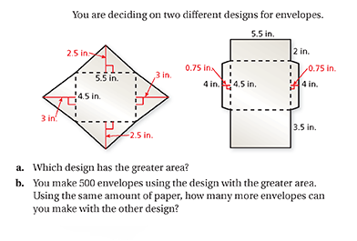
Answer a: the second design has the greater area.

Answer b: You could make 90 more envelopes with 1st design.
 | 3.5 | In addition to score 3.0 performance, in-depth inferences and applications with partial success.
Score 3.0 | The student can solve multi-step problems that involve finding the area of composite figures.  The student exhibits no major errors or omissions. |  | 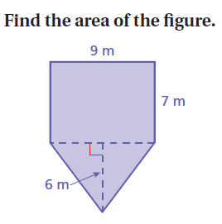Answer: 90 sq. meters
 | 2.5 | No major errors or omissions regarding 2.0 content and partial knowledge of the 3.0 content.
Score 2.0 | There are no major errors or omissions regarding the simpler details and processes. However, the student exhibits major errors or omissions regarding the more complex ideas and processes.  The student can find the area of simple shapes such as triangles and rectangles. |  | Find the area of right triangles and other triangles.  - Find the area of a triangle with a base of 5 cm and height 12cm.  Answer: 30cm squared
 | 1.5 | Partial knowledge of the 2.0 content, but major errors or omissions regarding the 3.0 content.
Score 1.0 | With help, a partial understanding of some of the simpler details and processes and some of the more complex ideas and processes.
 | 0.5 | With help, a partial understanding of the 2.0 content, but not the 3.0 content.
Score 0.0 | Even with help, no understanding or skill demonstrated.

