Content: Math |  |  | Grade Level: 6th
Standard: 6.EE.2a
Write expressions that record operations with numbers and with letters standing for numbers.
I can statements:
- I can translate a description into a mathematical expression.
- I can use a variable to represent an unknown quantity in an expression.
Score 4.0 | In addition to Score 3.0, in-depth inferences and applications that go beyond what was taught. |  |  | Sample Activities
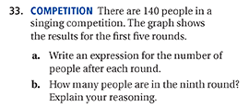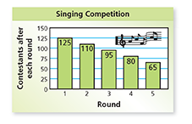
Answer: 140-15n, where n=round
 | 3.5 | In addition to score 3.0 performance, in-depth inferences and applications with partial success.
Score 3.0 | The student can solve multistep problems involving properties of operations.  The student exhibits no major errors or omissions. |  |  | A car is traveling at a speed of 55 miles per hour. Write an algebraic expression to show how far the car will travel for any number of hours.  Answer: 55x
 | 2.5 | No major errors or omissions regarding 2.0 content and partial knowledge of the 3.0 content.
Score 2.0 | There are no major errors or omissions regarding the simpler details and processes. Students are able to write an expression when give a phrase. However, the student exhibits major errors or omissions regarding the more complex ideas and processes. |  |  | Write as a numerical or algebraic expression:  32 subtracted from y  Answer: y -32
 | 1.5 | Partial knowledge of the 2.0 content, but major errors or omissions regarding the 3.0 content.
Score 1.0 | With help, a partial understanding of some of the simpler details and processes and some of the more complex ideas and processes.
 | 0.5 | With help, a partial understanding of the 2.0 content, but not the 3.0 content.
Score 0.0 | Even with help, no understanding or skill demonstrated.

