BPS Elementary Art Curriculum

My Snowy Day
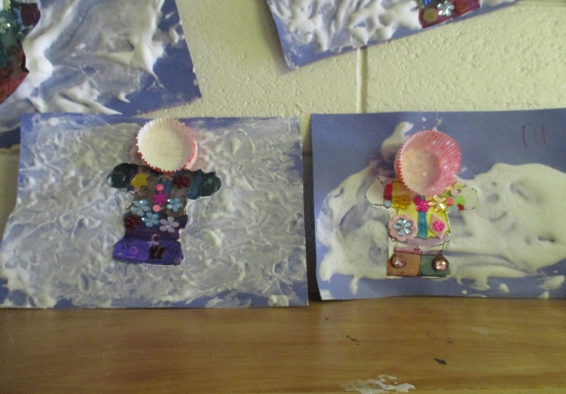
Art Standards:
ART-ES.1.04 Know how different visual art materials, techniques, and processes cause different responses.
ART-ES.1.06 Use visual art materials and tool in a safe and responsible manner.
ART-ES.1.01 Know differences between visual art media.
Alignment Standards:
Listening Comprehension

Materials: Water colors, paint brush, snow suit pattern, shaving cream, glue, muffin liner, miscellaneous decorations, student photo, bowl and spoon for mixing glue and shaving cream, and blue construction paper.
Grade: Kindergarten
Time: 40 minutes
Content Connections:
Literature Response

Art Elements | Art Principles
__Line | __Pattern
__Shape/Form | __Rhythm/movement
__Color | __Proportion/Scale
__Value | __Balance
__Texture | __Unity
__Space/Perspective | __Emphasis

Preparation
Vocabulary: 2D, 3D, embellishment, watercolor

I Cans
I can create a snowy day picture like Ezra Jack Keats.
I can use embellishments to decorate my snow suit.

Lesson description:
Students will water color a snow suit and create a 3D snow theme after reading A Snowy Day.
Teacher Background Knowledge
Mix equal parts shaving cream and glue, store in air tight container until ready to use.
Lesson
Day One: Read A Snowy Day then have students water color a snow suit.
Day Two: Students will decorate a snow suit with embellishments, add a muffin liner hood, and add photo of self in muffin liner. Add snow suit to a wet 3D snow scene made with the snow glue mixture.
Name___________________Lesson______________________
Assessment
Thumbs Down | Don’t Know | Thumbs Up | Assessment Question
 |  |  | Did you use your personal best during this lesson?
 |  |  | Did you actively listen and follow directions?
 |  |  | Did you use your creativity? (is it original?)
 |  |  | Did you complete your project?
 |  |  | Did you incorporate the art media?
 |  |  | Does the artwork show the elements and/or principles discussed?
Source

