BPS Elementary Art Curriculum

Swimming Goldfish
Grade: Kindergarten
Time: 2, 30 minute sessions
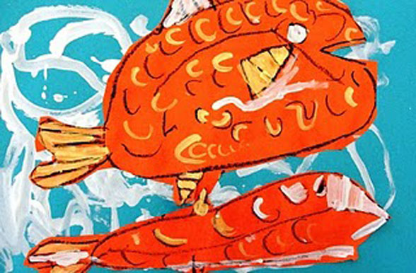
Content Connections:
Science: Goldfish
Writing: Nonfiction Research/Report

Art Standards:
Art-ES.1.02
Art-ES.1.03
Art-ES.1.05
Art-ES.1.06
Materials:
12x18 blue & orange construction paper
Paint: gold metallic, white, blue
Scissor, paint brush, water dish, glue, oil pastels

Art Elements | Art Principles
_x_ Line | ___Pattern
_x_ Shape/Form | _x_Rhythm/movement
_x_ Color | _x_Proportion/Scale
___Value | ___Balance
_x_ Texture | ___Unity
_x _Space/Perspective | ___Emphasis

Preparation:
Gather orange and blue paper, oil pastels, scissor, paints, paint brushes, have water dishes accessible.
Check website below:
http://www.deepspacesparkle.com/2010/04/27/upstream-salmon-art-project-for/
Vocabulary:
strokes, shapes, size

I Cans:
I can use a paintbrush safely and clean up appropriately.
I can create a goldfish using paint and paper.
I can show where goldfish live.

Lesson:
1. To begin, start with a bright orange piece of construction paper and a black oil pastel. Draw a circle for the salmon’s eye, a big round body, a tail and fins.
2. Then, using a small brush and white and gold metallic paint, create areas of color. Paint the eye, fins, add scales, etc.
3. When all the little salmon are happy, grab a pair of scissors and cut out all the fish.
4. When all the little salmon are happy, grab a pair of scissors and cut out all the fish.
Teacher Background Knowledge:
Parts of a goldfish.
Form of a goldfish.
Where goldfish live.

Name___________________Lesson______________________
Assessment
Thumbs Down | Don’t Know | Thumbs Up | Assessment Question
 |  |  | Did you use your personal best during this lesson?
 |  |  | Did you actively listen and follow directions?
 |  |  | Did you use your creativity? (is it original?)
 |  |  | Did you complete your project?
 |  |  | Did you incorporate the art media?
 |  |  | Does the artwork show the elements and/or principles discussed?

