**BPS Elementary Art Curriculum**

OliviaK

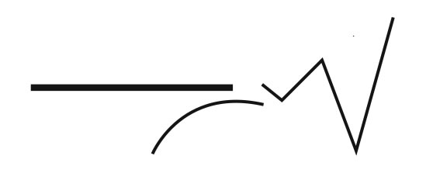

**Content Connections:**

**Language Arts:** Read Caldecott Honor book **Olivia** by Ian Falconer. This is a great book because Jackson Pollock’s art is featured. Also, it shows Olivia trying out this art style in her own way.

**Art Standards:** 4.2.1

Alignment Standards:

**Materials:**  plastic squeeze bottles, eye droppers, tongue depressors, string, toothbrushes, newspaper, manila or heavy white paper, paint (Use 3-4 colors), paintshirts

|  |  |
| --- | --- |
| **Art Elements** | **Art Principles** |
| _X_Line | __Pattern |
| __Shape/Form | _X_Rhythm/movement |
| _X_Color | __Proportion/Scale |
| _X_Value | __Balance |
| _X_Texture | __Unity |
| __Space/Perspective | __Emphasis |

**Grade:** Kindergarten

**Time:** 60 minutes

**Preparation:** Cut paper for painting (I use 8x8 in. for kindergarten). Lay out newspaper to avoid paint messes. Cut string into foot long pieces. Pour paint colors onto paper plates. At the Kindergarten level, having 4-5 painting stations where each student can have their own set of supplies, where the teacher can monitor and help if needed, works well.

**Vocabulary:** Jackson Pollock, Autumn Rhythm, line, action painting, contrast

**I Cans**

I can use art tools.

I can use art materials responsibly.

I can use colors to create visual art.

**Lesson description:**

This lesson is adaptable for all ages. It introduces students to a variety of art tools.

**Teacher Background Knowledge:**

This art lesson takes some preparation.

**Lesson**:

1. Read **Olivia** by Ian Falconer. Point out Jackson Pollock’s art.
2. Discuss Autumn Rhythm. Introduce vocabulary.
3. Google Autumn Rhythm images, students can see it and also how large it is hanging in a museum. This helps the students gain an appreciation for how big it is.
4. Talk about the different lines and patterns they see in the painting. Introduce the tools that the students will be using to create their own Jackson Pollock painting.
5. Demonstrate how to use each item with the paint and how to “paint” on the paper with them.
6. Have the students begin painting with the tools on the paper.
7. Encourage creativity and emphasize that there is no “wrong” way to do the art.
8. When students are done, let the paint dry thoroughly and then mount on 9x9 black paper.

Name___________________Lesson______________________

*Assessment*

|  |  |  |  |
| --- | --- | --- | --- |
| **Thumbs Down** | **Don’t Know** | **Thumbs Up** | **Assessment Question** |
|  |  |  | Did you use your personal best during this lesson? |
|  |  |  | Did you actively listen and follow directions? |
|  |  |  | Did you use your creativity? (is it original?) |
|  |  |  | Did you complete your project? |
|  |  |  | Did you incorporate the art media? |
|  |  |  | Does the artwork show the elements and/or principles discussed? |
|  |  |  |  |
|  |  |  |  |
|  |  |  |  |

Source