“Mittens on the Clothesline”
BPS Elementary Art Curriculum

MittensK
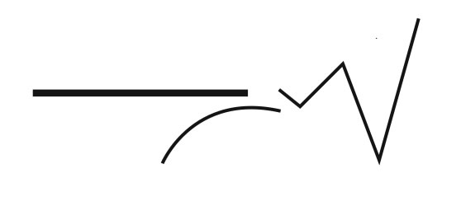
Content Connections: Reading
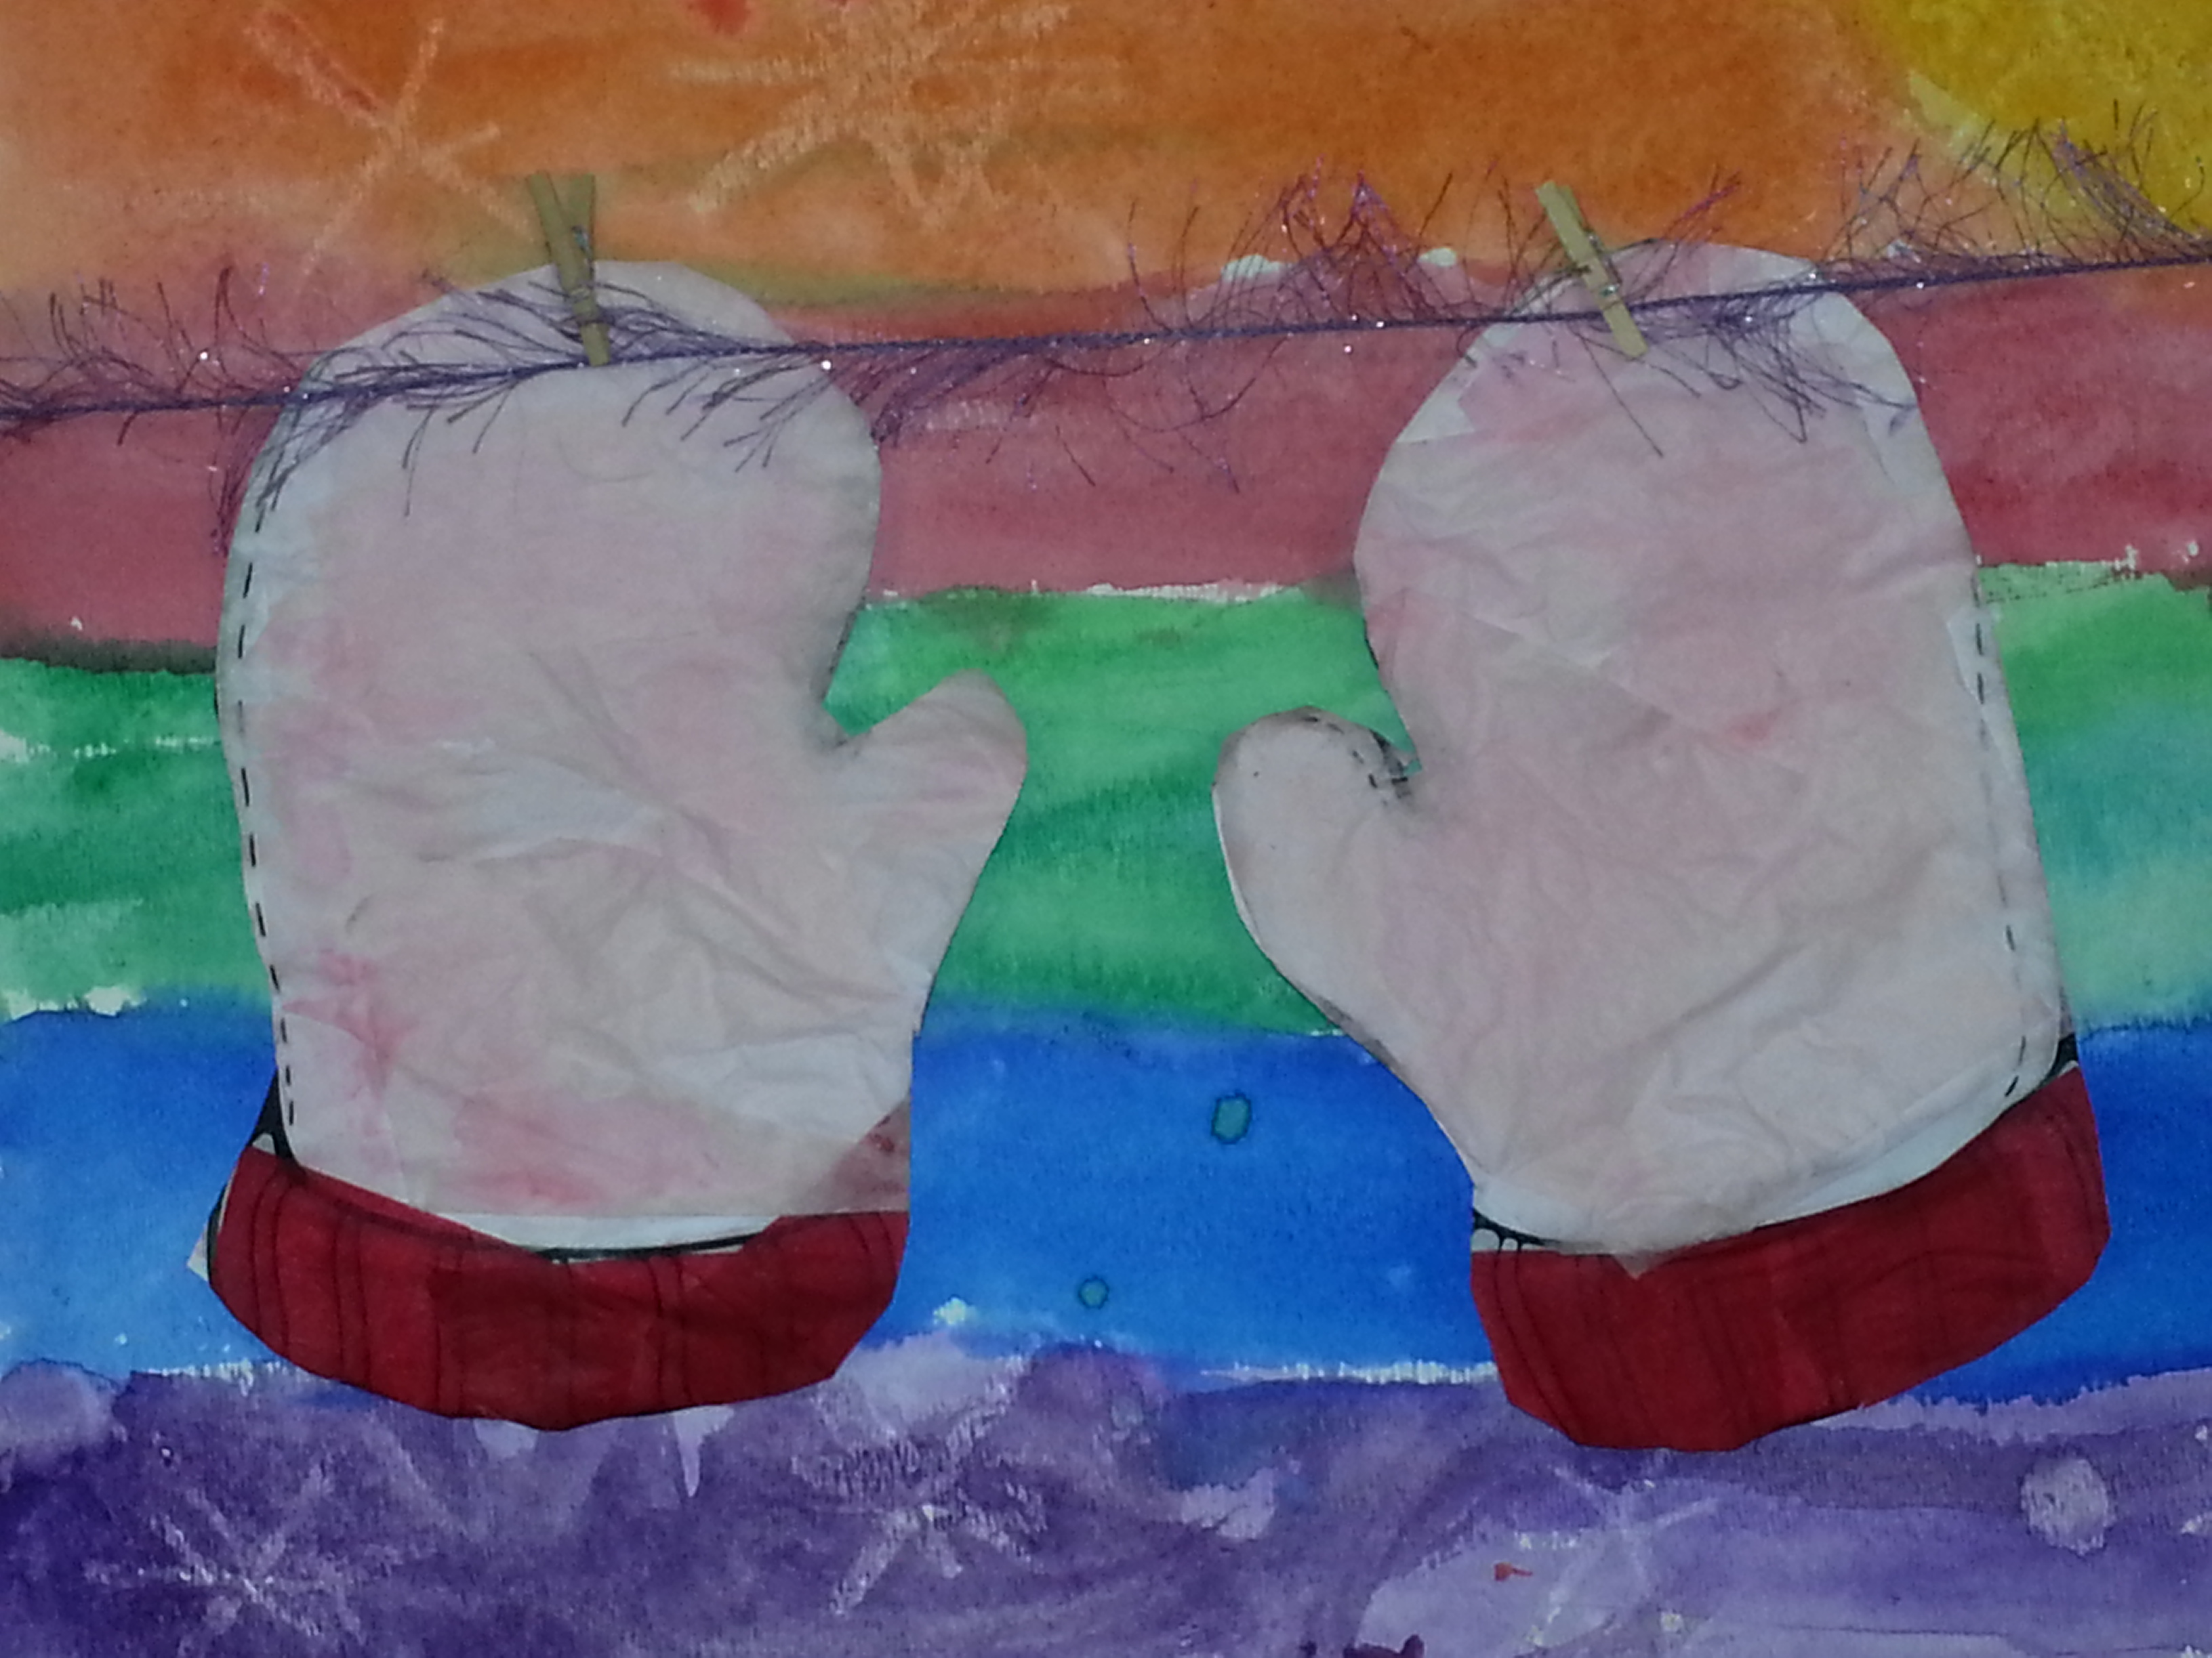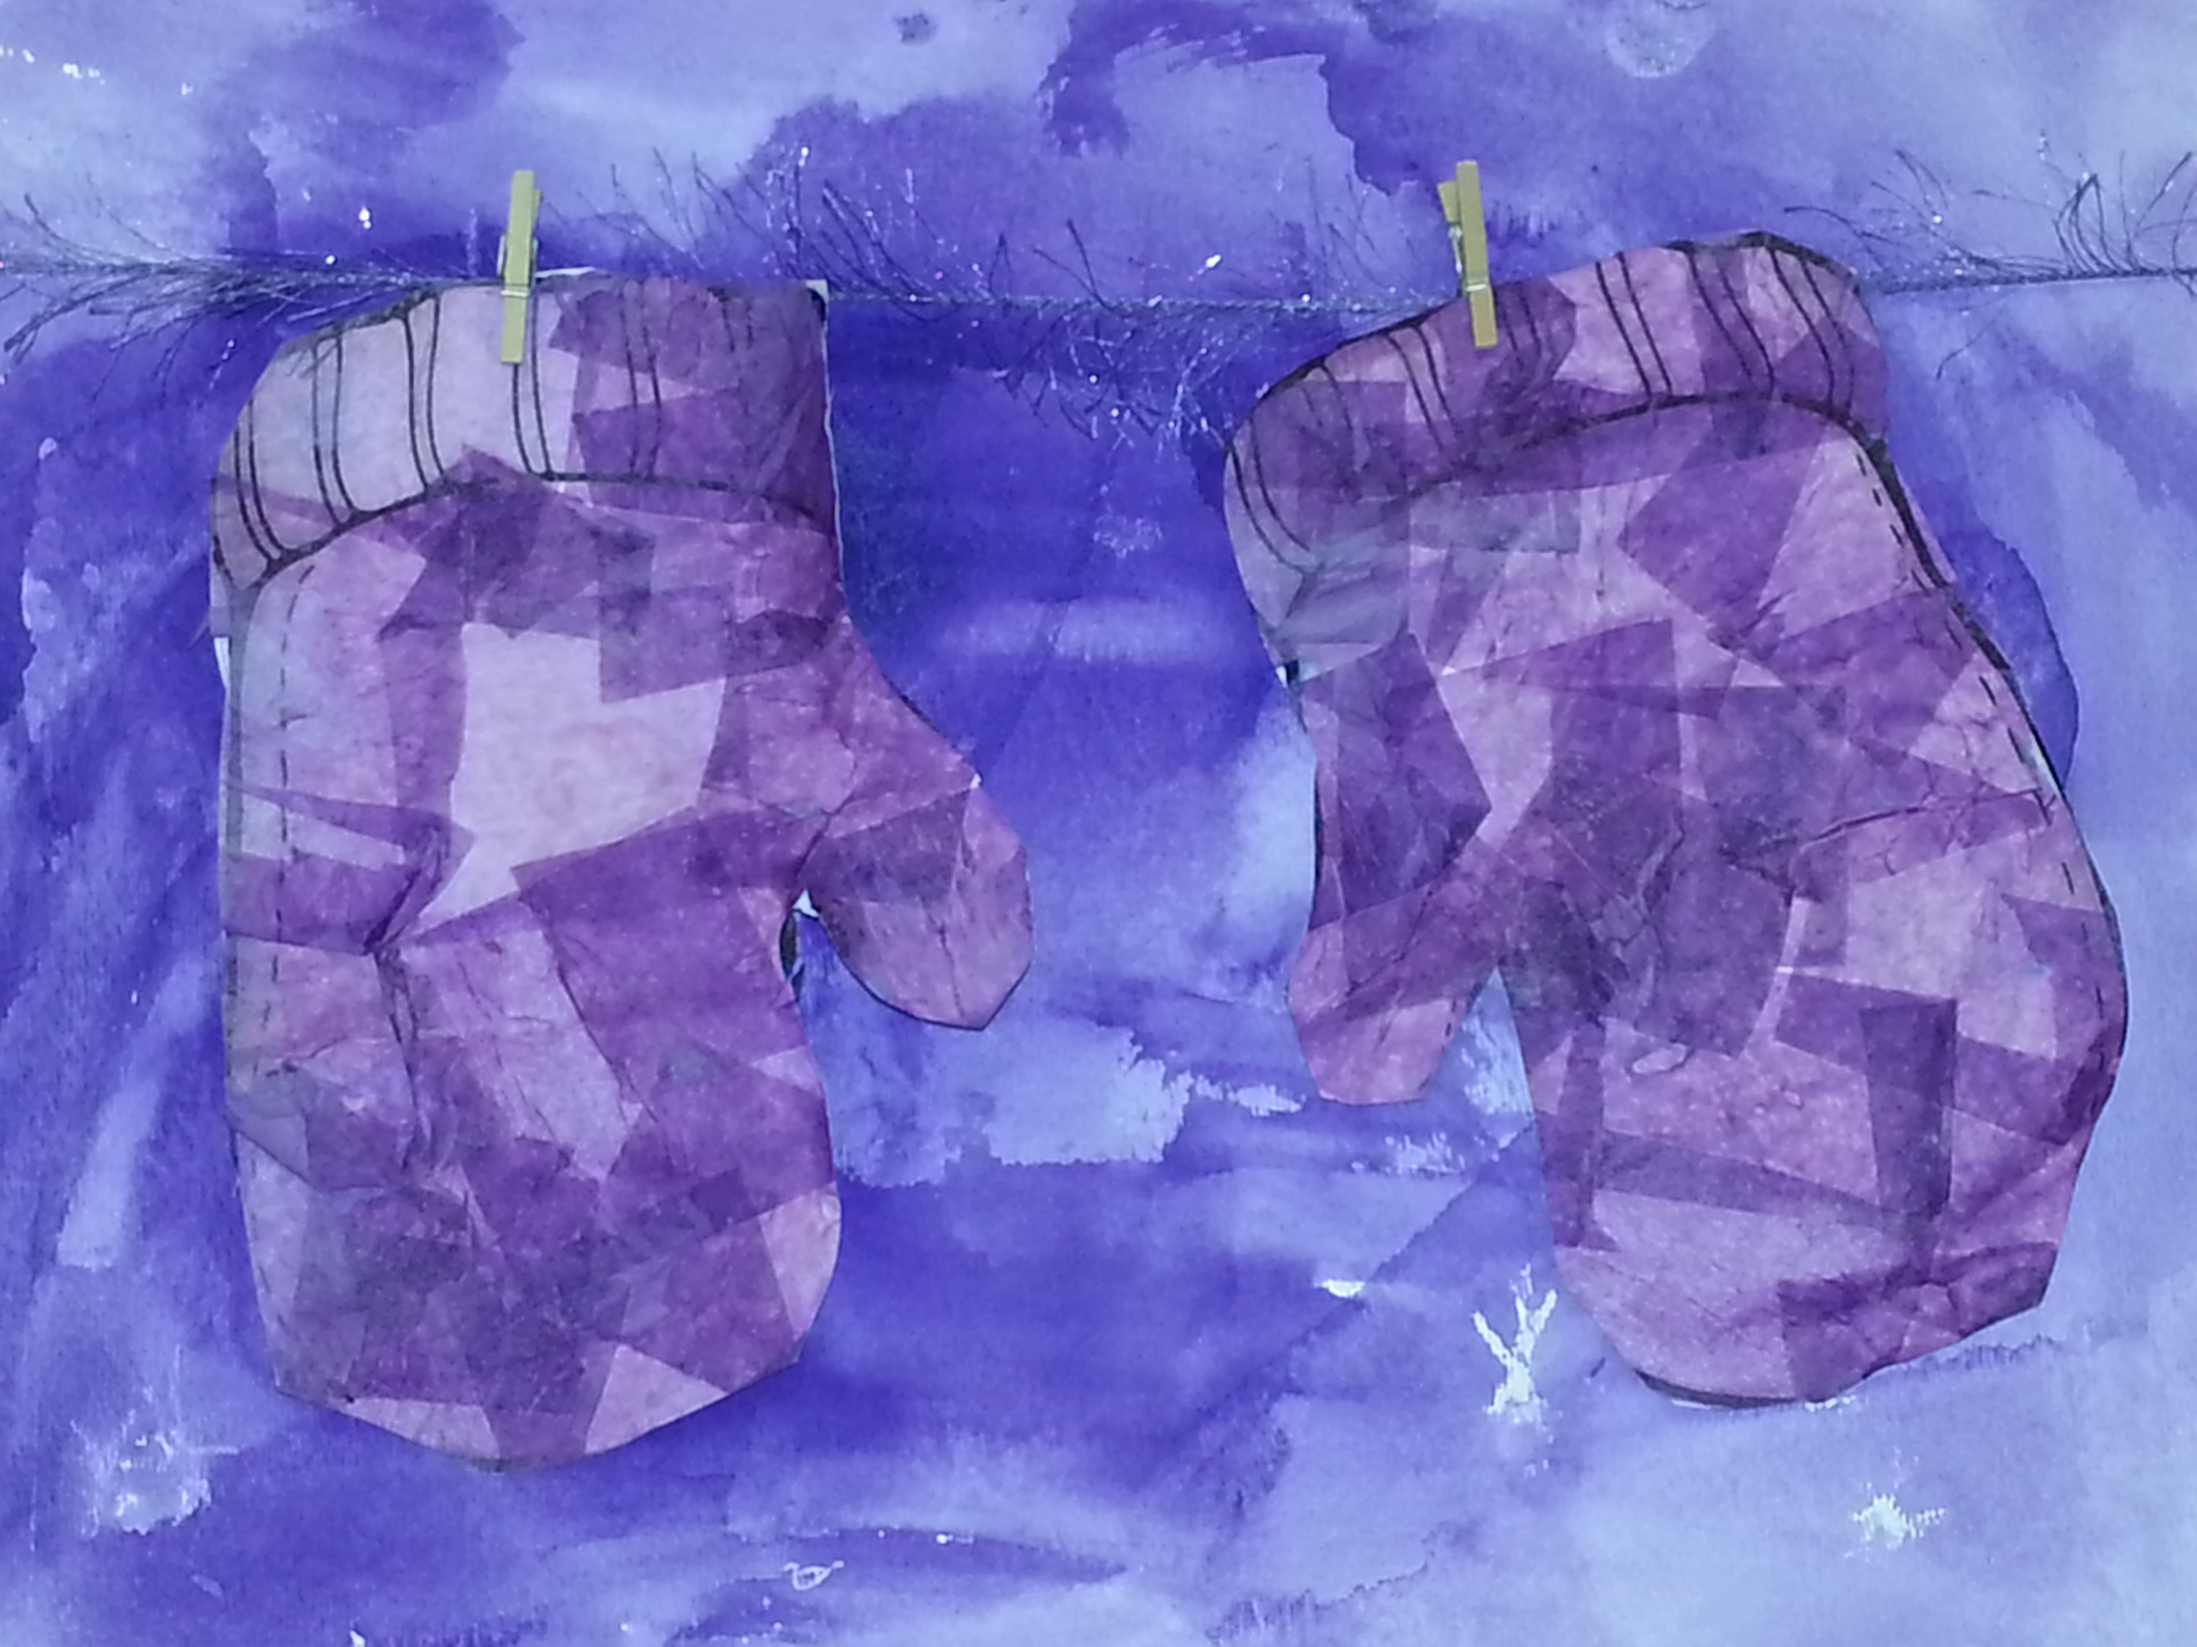

Art Standards: 4.1.5
Alignment Standards:
Materials: Watercolor paper, tissue paper (multi-colored), watercolor sets, water cups, water, paint brushes, yarn, mini clothespins, tape, mod podge or glue/water mixture, cups, black marker

Art Elements | Art Principles
X_Line | __Pattern
__Shape/Form | __Rhythm/movement
X_Color | __Proportion/Scale
__Value | __Balance
__Texture | __Unity
_XSpace/Perspective | __Emphasis

Grade: Kindergarten
Time: 1 hour
Preparation:
- Have precut 1-2 inch squares of multicolored tissue paper
- Have glue/water mixture mixed together and put into individual “glue” cups (one for each table to share)
- Have one brush for each child to use (have them set at each table spot)
- Have a copy of a pair of mittens for each child
- Have watercolor paper for each child
- Have a watercolor set for each child to use
- Precut yarn to fit across the page horizontally
- Small clothespins (two per child)
- Scotch tape
- Black felt tip marker
Vocabulary: symmetrical, matching, horizontal lines

I Cans

Lesson :
- Discuss Lines with students; discuss that we are going to be using horizontal lines to flow across the page-blending will take place using the watercolor paper (the students are free to use which colors they want to use)
- Students will make their “background” for their mittens page using the watercolor page: First they will use a white crayon to make snowflakes and then go over with the watercolors
- After they have completed their “background” page, they will set it to the side and let draw
- Meet again as a whole group to discuss “symmetry” and how our mittens come in pairs and the pairs match
- The students will then make their matching pair of their mittens using the “glue/water” mixture or mod podge to tissue paper their mittens; emphasize that they should be symmetrical
- After students have finished their mittens they should set them to the side to dry
- Meet as a group and read “The Mitten” by Jan Brett
- Once the story is finished they can complete their project by:
  - Cutting out their mittens
  - Taking their yarn and stringing it across the page horizontally (on the top half of their page)
  - Once they have strung their yarn across the page, the child will tape it on the pack of their page to hold the yarn
  - Then they will use a clothespin to clip their mittens onto the yarn
- Child will write the name on the lower left hand side in black marker
Lesson description:
*Watercolor background mediums with crayon resist

Teacher Background Knowledge:
Beginning Level
Name___________________Lesson______________________
Assessment
Thumbs Down | Don’t Know | Thumbs Up | Assessment Question
 |  |  | Did you use your personal best during this lesson?
 |  |  | Did you actively listen and follow directions?
 |  |  | Did you use your creativity? (is it original?)
 |  |  | Did you complete your project?
 |  |  | Did you incorporate the art media?
 |  |  | Does the artwork show the elements and/or principles discussed?
Source

