BPS Art Curriculum

Color Critters
Content Connections:
Math: Shapes
Art Standards: 4.1.5
Science standards:
Math: KG1, KG2, KG3
Materials: construction paper 12x18 black and 9x12 orange, white small pieces/scraps , oil pastels, scissors and glue

Art Elements | Art Principles
_x_Line | __Pattern
_x_Shape/Form | __Rhythm/movement
_x_Color | __Proportion/Scale
__Value | __Balance
__Texture | _x_Unity
__Space/Perspective | __Emphasis

Grade: K
Time: One session
Preparation:
Cut out 2” squares of white construction paper. Each student will need these for his or her creature’s eyes. From these squares, the students will cut eyes in whatever shape they like. They may use any number of eyes for their creature so make a lot. You can even use scraps of paper for this.

I Cans
I can mix primary colors in pairs to make the secondary colors.
I can mix all three primary colors together to make brown.
I can create a colorful creature using their imagination.
I can use art materials safely and clean up appropriately.
Vocabulary: primary, secondary, pattern, blend, oval

Lesson:
- Read and discuss White Rabbit’s Color Book by Alan Baker.
- Pass out or place on the tables in the middle of the groups the following items: 9x12 orange construction paper, scissors, glue, white construction paper (small pieces), oil pastels
- Give the following instructions:
  - We want to make large ovals today so choose a primary color pastel and try to touch your pastel on three sides of your paper as you draw a large oval shape.
  - Fill in a large part of this shape with red scribbling. Scribble right up to the edges.
  - Fill in a large part of the left over spaces in the shape with yellow scribbling. Leaving some space for blue, let the yellow overlap some of the red. What happens?
  - Now scribble the remainder of the space in the shape with blue. Cross over some red and some yellow as well. In one area try to mix all three colors.
  - What happens as you mix colors? Discuss this with your group.
  - Make sure the oval is completely filled and there are no “peek-a-boos” or spaces with the orange paper showing through the oil pastels.
- Show the children proper cutting techniques and cut out the oval shape.
- Glue large oval on to the 12x18 black paper, leaving room for heads and feet.
- Pass out small pieces of white paper to cut out the eyes. students can have as many eyes as they wish and can place them on their creature as they choose.
- Use the oil pastels to draw legs, feet, arms, hands head or whatever characteristics their creature has. Be sure that each part has at least two colors. For example, the head could be made of blue and yellow mixed together.
- Have fun with your critter
  - Display it with a write up
  - Name it
  - What does it eat?
  - Where does it live?
Lesson description:
Students will listen to the story White Rabbit’s Color Book in which White Rabbit jumps through primary color paints and turns brown. After some practice in mixing primary colored oil pastels in many combinations and discovering new colors, they will create a colorful critter from their practice sheet.
Teacher Background Knowledge:
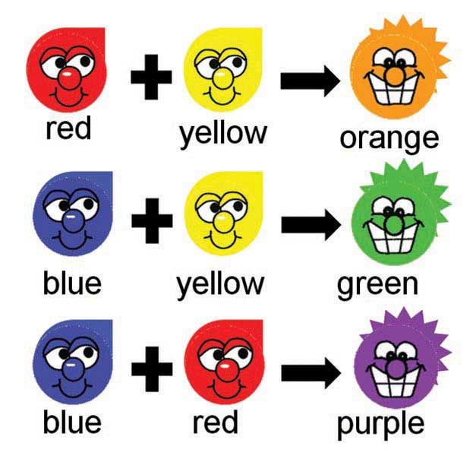
Name___________________Lesson______________________
Assessment
Thumbs Down | Don’t Know | Thumbs Up | Assessment Question
 |  |  | Did you use your personal best during this lesson?
 |  |  | Did you actively listen and follow directions?
 |  |  | Did you use your creativity? (is it original?)
 |  |  | Did you complete your project?
 |  |  | Did you incorporate the art media?
 |  |  | Does the artwork show the elements and/or principles discussed?
 |  |  | Can you find an oval shape?

