Content Connections:
Students connected the Social Studies theme of communities with their Reading skills, in the story “Abuela,” through painting the community they live in.

Roosevelt Elementary SALT Integrated Lesson Plan

Communities
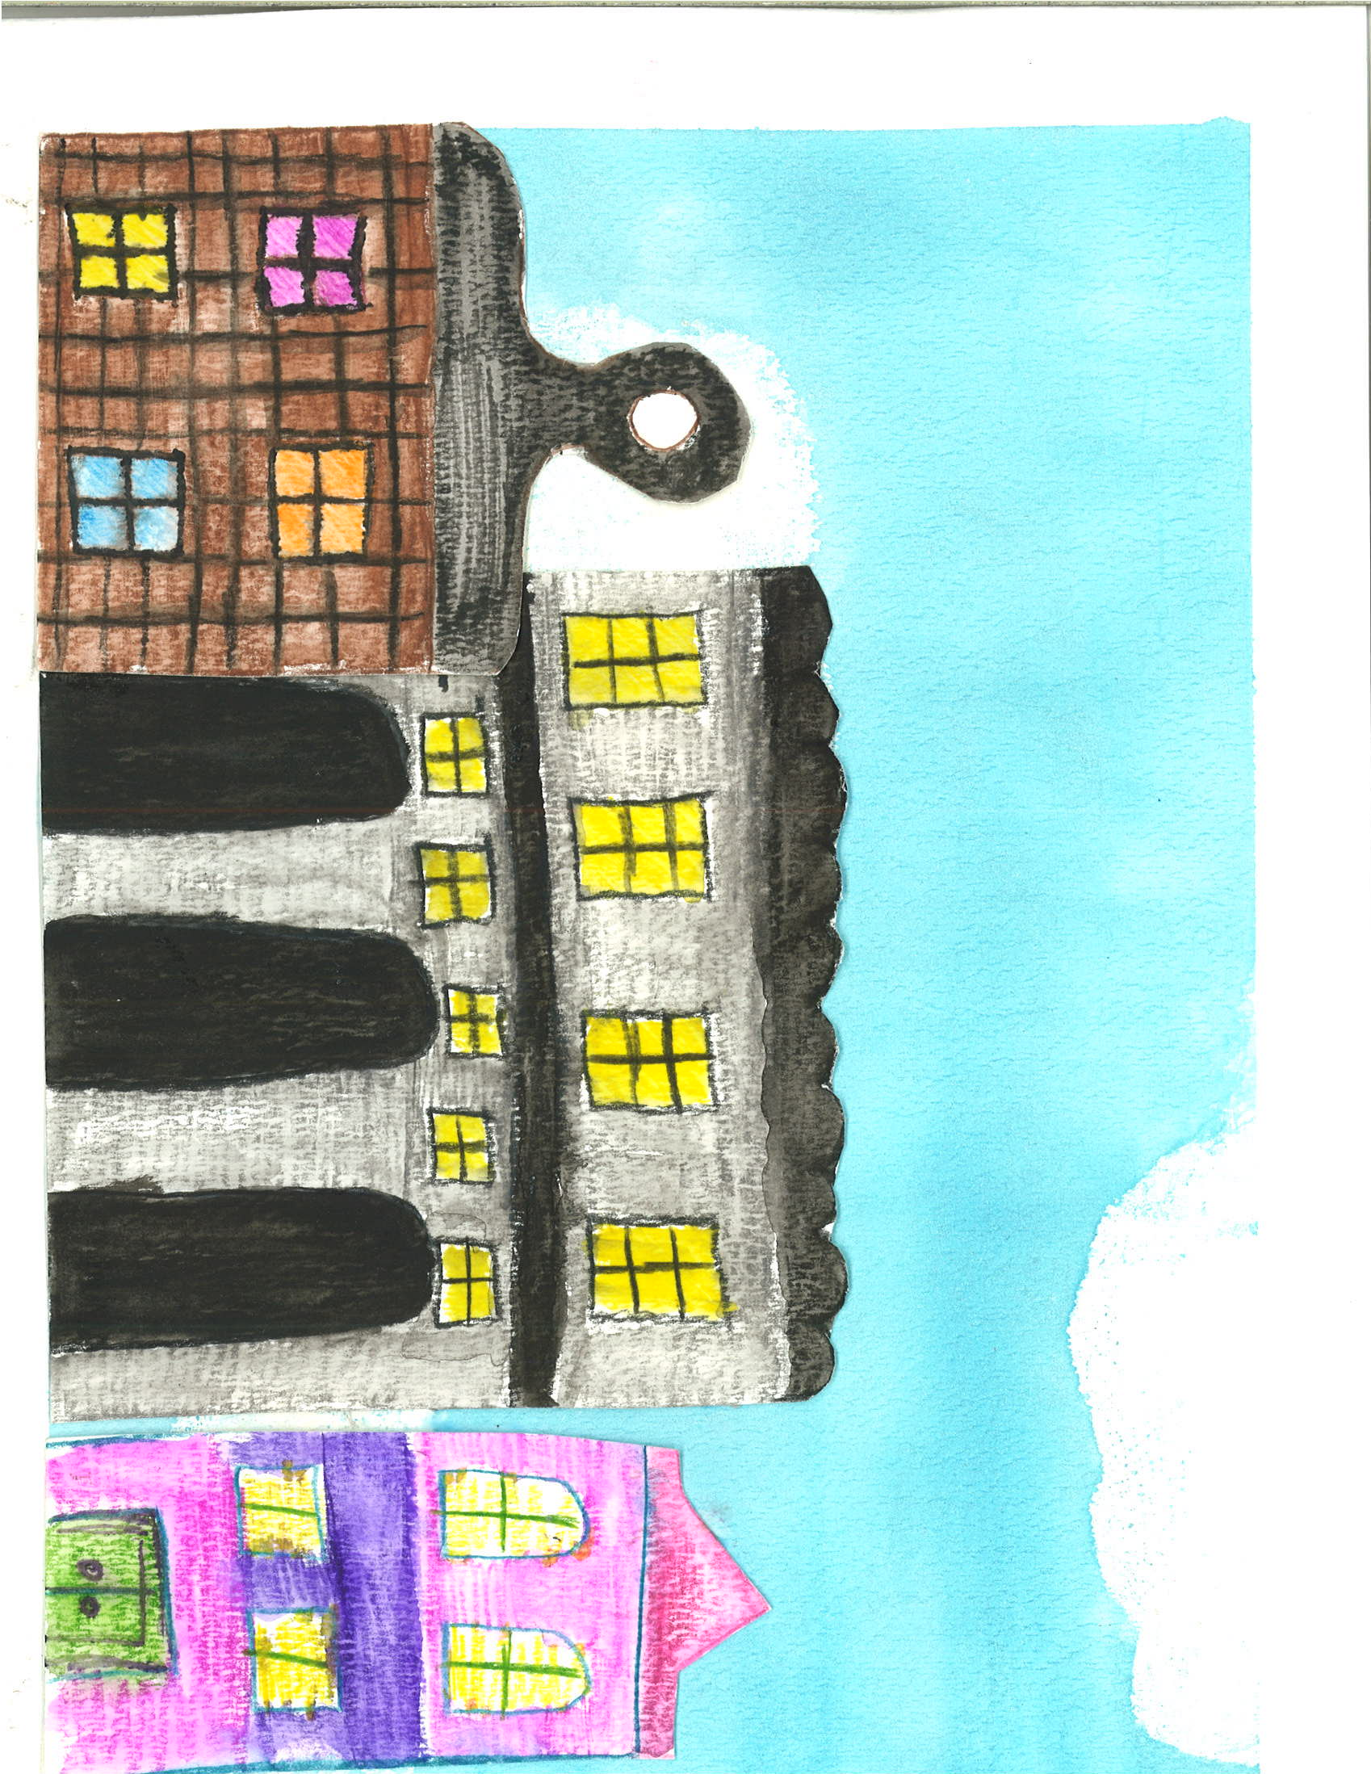
Art Standards: 4.1.5
Alignment Standards: ELA-00.RL.03 Identify the characters, setting, and major events.
ELA-00.RL.07 Describe the relationships of illustrations to the story.
K. G.2, 3 Identifies 2D shapes.

Materials: watercolor paper, watercolors, watercolor pencils, paint brushes
21st Century Skills
☒ Global Awareness
☐ Creativity and Innovation
☐ Critical Thinking and Problem
Solving

☐ Communication and Collaboration

☐ ICT Literacy

☐ Flexibility and Adaptability
☐ Initiative and Self-Direction
☐ Productivity and Accountability

☐ Understand the Art World

Artists Habits of Mind
☐ Engage & Persist
☐ Envision
☐ Express
☐ Observe
☐ Reflect
☒ Stretch & Explore
☐ Understand the Art World

Art Elements | Art Principles
__Line | __Pattern
_x_Shape/Form | __Rhythm/movement
_x_Color | _x_Proportion/Scale
__Value | _x_Balance
__Texture | __Unity
_x_Space/Perspective | __Emphasis

Grade: Kindergarten
Time: 2 hours
Vocabulary: communities-a social unit larger than a small village that shares common values. The term can also refer to the national community or international community.
Preparation: The teacher will gather materials needed for the activity, such as watercolors, watercolor paper. The teacher will also provide photos of interesting buildings in the community.

I Cans: I can draw the setting of a story using a variety of geometric shapes.

Lesson description: Students use watercolors to create buildings from their home community.

Teacher Background Knowledge:
-Know the art technique of wet-on-wet.
Lesson:
- Students will read the story in Scott Foresman, “Abuela.”
- The class will discuss the setting of the story.
-Introduce the concept of community to the class.
-After reading the story we will look at photos of the buildings in our community.
-Using the watercolor pencils and thinking back to geometric shapes, students will draw buildings in their community.
-Students will paint with water over their drawings and after they dry they will cut the buildings out.
-On another piece of watercolor paper the students will paint a blue background. Once the background is dry the students will glue on their buildings.

Name___________________Lesson______________________
Assessment
Thumbs Down | Don’t Know | Thumbs Up | Assessment Question
 |  |  | Did you use your personal best during this lesson?
 |  |  | Did you actively listen and follow directions?
 |  |  | Did you use your creativity? (is it original?)
 |  |  | Did you complete your project?
 |  |  | Did you incorporate the art media?
 |  |  | Does the artwork show the elements and/or principles discussed?
Source

