BPS Elementary Art Curriculum

Echo Draw
Content Connections:
Holidays
Shapes
Math
Art Standards: ES.1.02, ES.1.04
Alignment Standards: Know the different techniques used to create visual art. Know the different visual art materials, techniques, and processes cause different responses.
Materials: Document camera for “echo draw”
Watercolor paper, paintbrushes, watercolor,
Pencil first, then oil pastels

Art Elements | Art Principles
_X_Line | _X_Pattern
_X_Shape/Form | _X_Rhythm/movement
_X_Color | _X_Proportion/Scale
__Value | _X_Balance
_X_Texture | __Unity
_X_Space/Perspective | _X_Emphasis

Grade: Kindergarten
Time: 1 hour
Preparation
Prepare supplies, water in cups, paintbrushes and paints at tables.
Vocabulary:
Shapes, water resist, brush strokes, lines

I Cans
Follow directions
Draw basic shapes
Identify holiday characters
Use correct brush strokes
Use different art tools

Lesson description:
See Lesson to the right
Teacher Background Knowledge
Art tools
Shapes
How to properly instruct an echo draw
Lesson
- Start with pencil for echo draw. Step by step using basic shapes
- Trace over pencil lines with oil pastels
- Watercolor reindeer and background

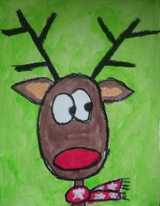
Name___________________Lesson______________________
Assessment
Thumbs Down | Don’t Know | Thumbs Up | Assessment Question
 |  |  | Did you use your personal best during this lesson?
 |  |  | Did you actively listen and follow directions?
 |  |  | Did you use your creativity? (is it original?)
 |  |  | Did you complete your project?
 |  |  | Did you incorporate the art media?
 |  |  | Does the artwork show the elements and/or principles discussed?
Source

