**BPS Elementary Art Curriculum**

Hearts

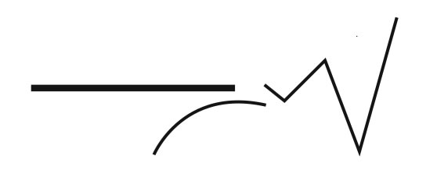

Materials:

Pre-cut large hearts from 12x18 paper

Tempera paints

Paintbrushes

Pablo Picasso children’s book or pictures

Grade: Kindergarten

Time: 45 min. – 1 hour

Content Connections:

Language Arts – There are many books on Pablo Picasso that can be read aloud to students. One example is *Pablo Picasso* by Ernest Raboff.

Art Standards:4.2.1

Alignment Standards:

|  |  |
| --- | --- |
| **Art Elements** | **Art Principles** |
| _X_Line | __Pattern |
| __Shape/Form | __Rhythm/movement |
| _X_Color | __Proportion/Scale |
| __Value | __Balance |
| __Texture | __Unity |
| __Space/Perspective | __Emphasis |

Preparation

Pre-cut large hearts (from 12x18) paper (cardstock paper works best)

Tempera paints (including white and black)

Various paint brushes for each table

Vocabulary:

Line and Color

I Cans

I can create an art project using line and color.

I can use art materials responsibly.

Lesson description:

Students will create a project practicing different lines and color mixing techniques.

Teacher Background Knowledge

Lesson

Review lines (model the different lines while using different brushes)

Discuss how they will be able to use the various paint colors and to think about how when adding white to colors what will happen.

Students freely explore the brushes/paints to create their “kinder heart”

Lesson can be found on [www.deepspacesparkle.com](http://www.deepspacesparkle.com)” under “kinder hearts”

Name___________________Lesson______________________

*Assessment*

|  |  |  |  |
| --- | --- | --- | --- |
| **Thumbs Down** | **Don’t Know** | **Thumbs Up** | **Assessment Question** |
|  |  |  | Did you use your personal best during this lesson? |
|  |  |  | Did you actively listen and follow directions? |
|  |  |  | Did you use your creativity? (is it original?) |
|  |  |  | Did you complete your project? |
|  |  |  | Did you incorporate the art media? |
|  |  |  | Does the artwork show the elements and/or principles discussed? |
|  |  |  |  |
|  |  |  |  |
|  |  |  |  |

Source