**BPS Elementary Art Curriculum**

Life Cycle

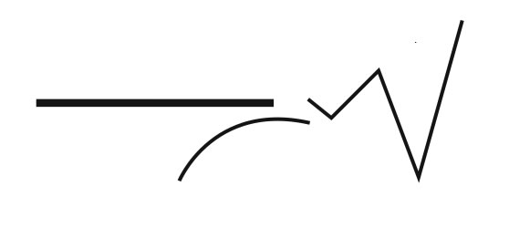

Content Connections:

Science: Life Cycle of a chick

Art Standards: 4.1.5

Alignment Standards:

Materials: Construction paper-yellow and orange, glue, crayons, pencil, markers

|  |  |
| --- | --- |
| **Art Elements** | **Art Principles** |
| _x_Line | _x_Pattern |
| _x_Shape/Form | __Rhythm/movement |
| __Color | _x_Proportion/Scale |
| __Value | _x_Balance |
| __Texture | __Unity |
| _x_Space/Perspective | __Emphasis |

Grade: K

Time: 30-45 minutes

Preparation

Collect and cut paper   
gather glue, markers, crayons, and scissors

Vocabulary: chick, hatch, oval, accordion fold, line, curve, cut

I can: trace, cut, fold, flip, and glue.

Lesson description: Describe the parts of a chick and draw and cut the parts to assemble.

Teacher Background Knowledge: information about chicks-body parts, size, shape.

Lesson

1. Cut the body out
2. Trace your hands. Cut them out. Glue to the body.
3. Cut the beak and glue on.
4. Color the body
5. Fold the legs and glue on
6. Cut the feet and glue on.

Name___________________Lesson______________________

*Assessment*

|  |  |  |  |
| --- | --- | --- | --- |
| **Thumbs Down** | **Don’t Know** | **Thumbs Up** | **Assessment Question** |
|  |  |  | Did you use your personal best during this lesson? |
|  |  |  | Did you actively listen and follow directions? |
|  |  |  | Did you use your creativity? (is it original?) |
|  |  |  | Did you complete your project? |
|  |  |  | Did you incorporate the art media? |
|  |  |  | Does the artwork show the elements and/or principles discussed? |
|  |  |  |  |
|  |  |  |  |
|  |  |  |  |

Source