BPS Elementary Art Curriculum
*SALT Grant Lesson

Lines that wiggle
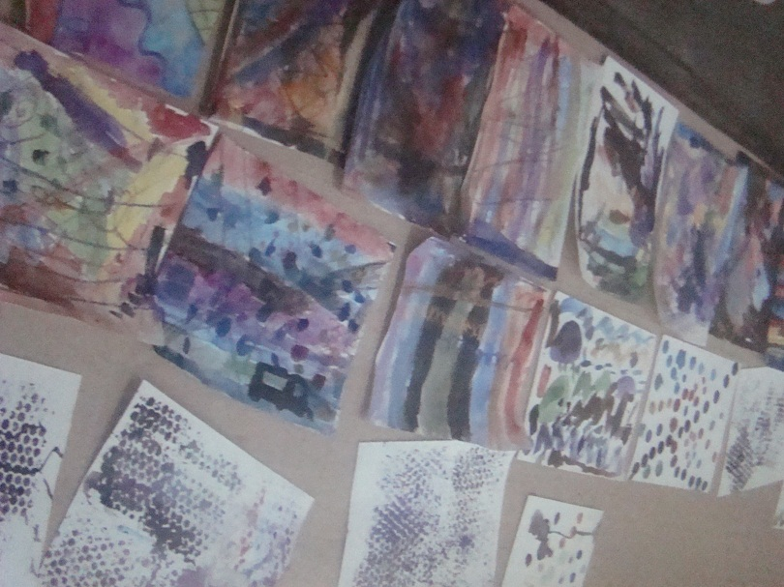
Materials:
Watercolors, bowls for water, flat paintbrushes, round brushes, fan paintbrushes, sponge dabbers, bubble wrap, watercolor paper
Art Standards: 4.1.5
Alignment Standards:
4.1.2 Know the different techniques used to create visual arts

Content Connections:
Students will make connections to the social studies curriculum, learning and practicing the life skill of responsibility.
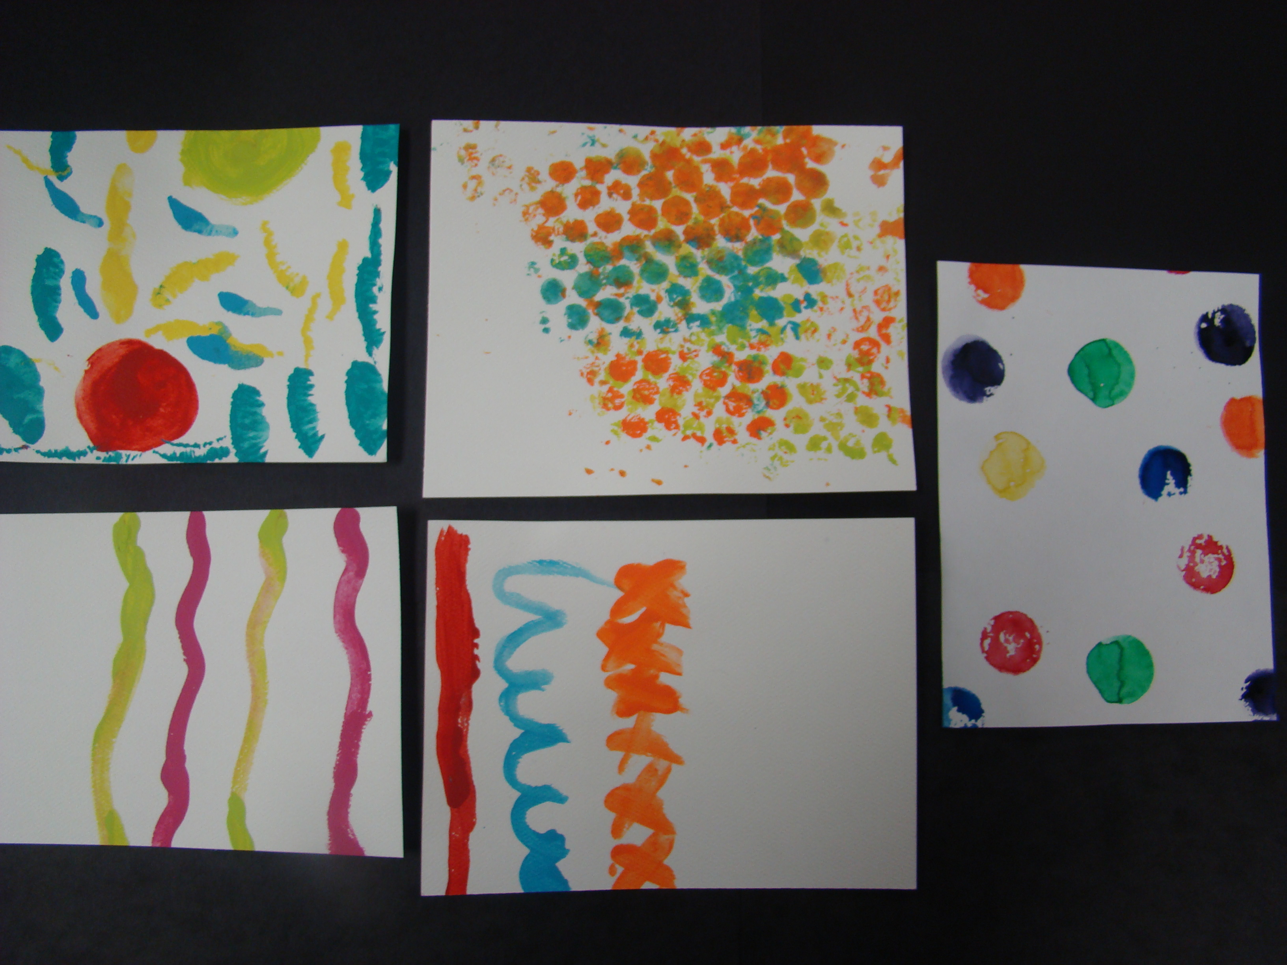

Art Elements | Art Principles
_x_Line | _x_Pattern
__Shape/Form | __Rhythm/movement
__Color | __Proportion/Scale
__Value | __Balance
_x_Texture | __Unity
__Space/Perspective | __Emphasis

Vocabulary:
Flat brush-bristles are arranged so the brush is quite wide
Round brush-enabling you to paint fine lines and detail
Fan brush-a brush with a thin layer of bristles spread out

Lesson
First, gather students to introduce the proper way of using watercolor paints. Showing the empty water bowl, explain to the students that watercolors need water in order to work. Point to the line in the bowl and tell a student to fill the bowl up to the line. Ask the students why they think we don’t fill the bowl up to the top? (So the water doesn’t spill when we are walking to our tables.)
Dipping a brush into the bowl wet the paintbrush and dab the brush onto a color in the paint tray. Tell students to continue to dab the brush into the bowl of water and wet each color. Rinse the brush each time to ensure no paint transfers from color to color. If paint should get into a different color, demonstrate how to clean up the color by using the paintbrush and sweeping the unwanted color up and rinsing the brush in water. Continue until the original color is clean.
Using the watercolors, show students how to use the flat brush by dipping it into a color and sweeping it across the watercolor paper. Students should concentrate on making lines of color by sweeping back and forth. Discuss with the students why it is important to drag the bristles in one direction when using the brush. (To keep the bristles from fanning out in different directions) Have students gather their materials and experiment with a flat brush. Give them approximately ten minutes and gather together for another demonstration.
Read the story Lines that Wiggle to the class.
Next, use the round brush, by dipping it into the paint and dragging it across the watercolor paper. Show students how to make thin lines with the end of the brush and thick lines by pressing the entire brush on the paper. Demonstrate a variety of lines: thick and thin lines. Ask students what other kinds of lines were mentioned in the story? (wavy, swirly, zig zag, curvy) Paint some of the types of lines students answered. Send students back to their tables to use a round brush. Encourage a variety of lines. Tell students that using a paintbrush is like drawing with a pencil.
Once again, gather children. Using a 5”x5” piece of bubble wrap, paint the bubble wrap, bumpy side up. Picking the bubble wrap up, press it to the paper. Lift the wrap and show the circles that were created. Show students that the bubble wrap can have multiple colors painted upon it and can be turned in different directions. Now, using a sponge dabber, dip the sponge in the watercolors and press on the paper. Send students to experiment with both bubble wrap and sponge dabbers. Give students more paper to create using the techniques above. This paper can be used for additional projects in the future.

Preparation
Using a permanent marker, make a line in the water bowls to give students of visual, as to where the water should be filled to.

Lesson description
Students learn a variety of different techniques to paint with watercolors, while practicing the life skill of responsibility, by taking care of the brushes, watercolor trays, and work area.

Activities That Finished Paper Can Be Used For:
-Snowflakes (Patterns)
-Letters in Names (Chrysanthamum)
-Background Paper for any art activity

Teacher Background Knowledge
Teachers should have an understanding of basic painting strokes and painting techniques, such as wet on wet. Additional examples: flat brush creates wide lines, round brush creates thin/narrow lines and fan brush creates circles and stipple marks.
I Cans
I can use painting techniques to create a picture.
I can be a responsible learner by cleaning up my work area and art tools.

Name___________________Lesson______________________
Assessment
Thumbs Down | Don’t Know | Thumbs Up | Assessment Question
 |  |  | Did you use your personal best during this lesson?
 |  |  | Did you actively listen and follow directions?
 |  |  | Did you use your creativity? (is it original?)
 |  |  | Did you complete your project?
 |  |  | Did you incorporate the art media?
 |  |  | Does the artwork show the elements and/or principles discussed?

