Stud
Content Connections:
Students will connect their knowledge of the alphabet with their art experience.
Roosevelt Elementary SALT Integrated Lesson Plan

Print Making
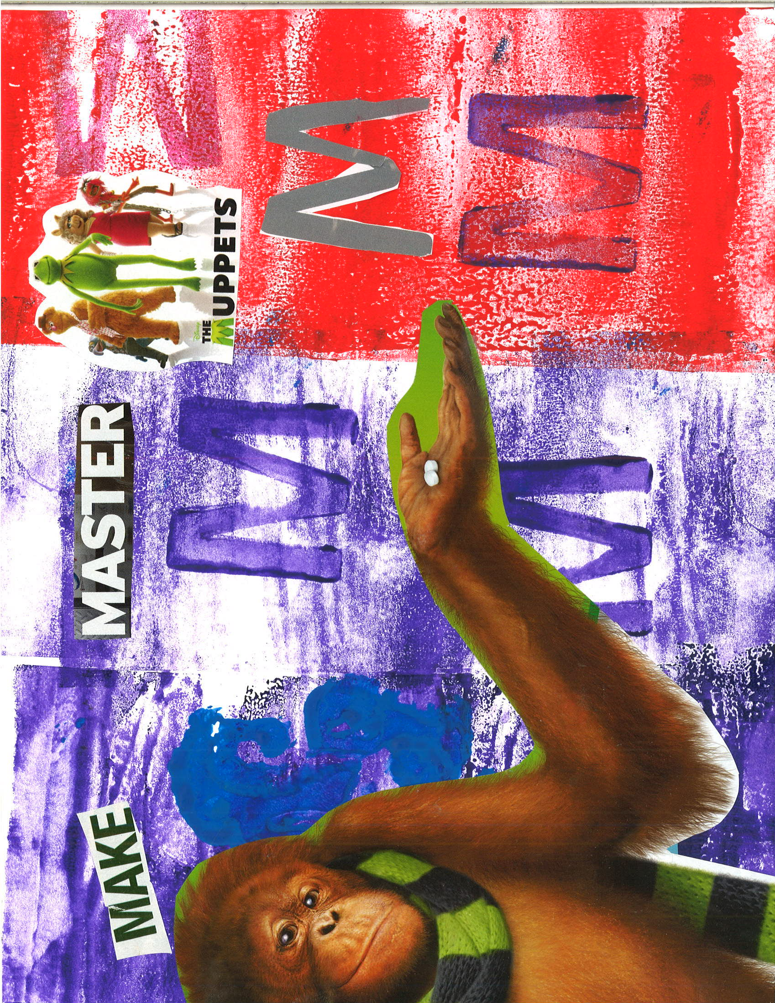
Materials: Brayers, alphabet stamps and everyday objects to use for painting. Examples of objects include fly swatter, bubble wrap and the bottom of shoes. Magazines or newspaper

21st Century Skills
☐ Global Awareness
☒ Creativity and Innovation
☐ Critical Thinking and Problem
Solving

☐ Communication and Collaboration

☐ ICT Literacy

☐ Flexibility and Adaptability
☐ Initiative and Self-Direction
☐ Productivity and Accountability

☐ Understand the Art World

Artists Habits of Mind
☐ Engage & Persist
☐ Envision
☐ Express
☐ Observe
☐ Reflect
☒ Stretch & Explore
☐ Understand the Art World

Art Standards: 4.1.5
Alignment Standards: K.RF.1D and K.RF.3A

Art Elements | Art Principles
__Line | __Pattern
_X Shape/Form | __Rhythm/movement
__Color | __Proportion/Scale
__Value | _X_Balance
__Texture | __Unity
__Space/Perspective | __Emphasis

Grade: Kindergarten
Time: Two to three days
Vocabulary:
Print making-Printmaking is an indirect means of creating art by transferring an image or design by contact with a matrix such as a stamp, rock, or screen.
Collage-A form of art in which various materials such as photographs and pieces of paper or fabric are arranged and stuck to a backing.
Preparation
Lay a large piece of plastic across a table. Squeeze print making ink on plastic to roll brayers or place stamps in.
Give each student a letter in the alphabet to work on.

I Cans
I can find objects and pictures that begin with letters.

I can use a variety of art techniques to create prints.

Lesson description: Students will use print making techniques to create an alphabetic print.

Teacher Background Knowledge
Lesson
After students are given a specific letter, they use a brayer to create the background of their art. Next, they look through a pile of alphabet letter stamps to find their letter. Students use the stamp to display their letter on their page. After, students find objects or stamps that begin with their letter sound and use to create a collage. After paint had dried, students will look through magazines or newspapers to find letters, words, and pictures that correspond to their letter. Students arrange the cutouts on paper and glue them down.
Name___________________Lesson______________________
Assessment
Thumbs Down | Don’t Know | Thumbs Up | Assessment Question
 |  |  | Did you use your personal best during this lesson?
 |  |  | Did you actively listen and follow directions?
 |  |  | Did you use your creativity? (is it original?)
 |  |  | Did you complete your project?
 |  |  | Did you incorporate the art media?
 |  |  | Does the artwork show the elements and/or principles discussed?
Source

