BPS Elementary Art Curriculum

Reindeer
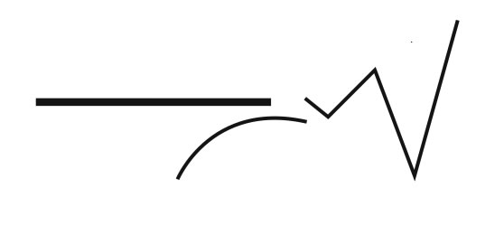
Content Connections:
Science: Animals
Art: Mixed mediums
Math: Geometry

Art Standards: 4.1.1, 4.1.2, 4.1.5, 4.2.1, 4.2.2,
4.3.1
Alignment Standards:
Materials: Christmas books (reindeer themed) watercolor, Tempera paint, crayon, paper, pencils

Art Elements | Art Principles
_x_ Line | _x_Pattern
_x_ Shape/Form | __Rhythm/movement
_x_ Color | __Proportion/Scale
_x Value | _x_Balance
__Texture | _x_Unity
_x_ Space/Perspective | _x_Emphasis

Grade: First
Time: one hour
Preparation
Reading books, singing songs, gathering art supplies.
Vocabulary: reindeer, Christmas, holidays,
Herd, oval, size, proportion,

I Cans …
Use different art tools and supplies to create a picture.
Be aware of shapes and sizes.
Give characters expression.

Lesson description: During the holiday several reindeer themed books were read. We created a heard of reindeer to hang in our hallway to go along with the season and holiday.

Teacher Background Knowledge
Lesson
We gathered paper, pencils, and a black crayon. We worked on sketching our reindeer first. We started by talking about the space we had on our paper. We began with a large oval. Next we added lines for the antlers, shapes for the ears, neck, and nose. We then traced our lines with a black crayon.
We came back to our art later and started by adding water color for the background and the face. Finally, we added tempera paint to make some of the pieces pop. (red noses, scarves.) The students then gave their reindeer a little bit more character by adding different details to their eyes. (wide, narrow, looking around, eye lashes, ect…)

Name___________________Lesson______________________
Assessment
Thumbs Down | Don’t Know | Thumbs Up | Assessment Question
 |  |  | Did you use your personal best during this lesson?
 |  |  | Did you actively listen and follow directions?
 |  |  | Did you use your creativity? (is it original?)
 |  |  | Did you complete your project?
 |  |  | Did you incorporate the art media?
 |  |  | Does the artwork show the elements and/or principles discussed?
Source

