**BPS Elementary Art Curriculum**

Sam Come Back! Cat Art

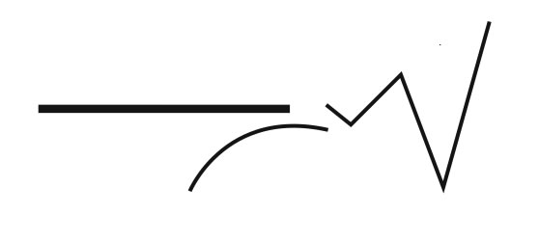

Content Connections:

Reading “Sam Come Back!” story

Art Standards: 4.1.5

Alignment Standards:

4.6.2

4.2.1

Materials:

Permanent markers, card stock circles for tracing, pencils, construction paper, Cray Pas oil pastels

|  |  |
| --- | --- |
| **Art Elements** | **Art Principles** |
| _+_Line | __Pattern |
| _+_Shape/Form | __Rhythm/movement |
| _+_Color | _+_Proportion/Scale |
| __Value | __Balance |
| __Texture | __Unity |
| _+_Space/Perspective | __Emphasis |

Grade: 1st

Time: 45 minutes

Preparation

Read “Sam Come Back!”

Vocabulary:

Contrast, proportion, oil pastels, permanent markers

I Cans

I can use contrasting colors.

I can draw a cat that fills up my paper.

Lesson description:

Students will use their knowledge of cats to help them as they learn how to use shapes to draw a cat with contrasting colors.

Teacher Background Knowledge

Teacher will practice using cray pas (oil pastels) prior to the lesson.

Teacher will read “Sam Come Back!” with class.

Lesson

Fold paper into quarters and draw black lines to separate the paper into four quadrants.

Students trace a circle for the cat’s head.

Students draw neck, body, and tail. Students add facial features.

Trace sketch with permanent marker.

Color with oil pastels.

Name___________________Lesson______________________

*Assessment*

|  |  |  |  |
| --- | --- | --- | --- |
| **Thumbs Down** | **Don’t Know** | **Thumbs Up** | **Assessment Question** |
|  |  |  | Did you use your personal best during this lesson? |
|  |  |  | Did you actively listen and follow directions? |
|  |  |  | Did you use your creativity? (is it original?) |
|  |  |  | Did you complete your project? |
|  |  |  | Did you incorporate the art media? |
|  |  |  | Does the artwork show the elements and/or principles discussed? |
|  |  |  |  |
|  |  |  |  |
|  |  |  |  |

Source