BPS Art Curriculum

Shape Kabobs
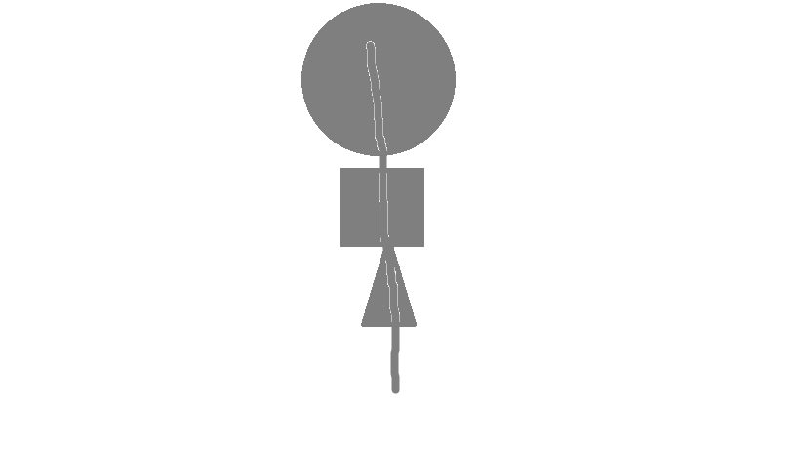
Materials: crayons, , tag board, 1x12, copy paper, half sheets, glue, scissors, bags, textured paper
Content Connections:
Math

Art Standards:
4.1.2
Alignment Standards:
Math: KG4, KG5

Art Elements | Art Principles
__Line | __Pattern
_x_Shape/Form | __Rhythm/movement
_x_Color | __Proportion/Scale
__Value | __Balance
_x_Texture | __Unity
__Space/Perspective | __Emphasis

Grade: K
Time: 1 session
Preparation:
Cut tag board into 12x1 inch pieces to use later as sticks for shape kabobs. Cut plain copy paper into pieces 8.5 x 5.5 inches or one-half sheet. Peel off paper from crayons because you might use them for texturing paper. Cut basic shapes from textured paper like sandpaper, wallpaper and place in “texture” bag.
Vocabulary: Texture, shape

I Cans
I can find and name textures.
I can make color rubbings from different shaped textures.
I can assemble textures shapes onto a stick.
Lesson description:
Students will discover texture by rubbing crayons over pre-cut textured shapes

Teacher Background Knowledge
Textures can be real or implied. A real texture can be felt. An implied texture looks rough or bumpy, but is not. It is drawn to look that way.

Lesson:
- Ask students to touch the bottom of their shoes and to use a word that describes how that feels. Does it feel rough, smooth, bumpy, scratchy…
- Tell them they will be going on a treasure hunt today, but it will be called a “texture Hunt.” Have students wander around the room finding textures. Stop them a few times and have them show and name their textures.
- Set up class so 4 students share each texture bag.
- Select a textured shape from the bag and put it completely under the copy paper.
- Using the side of a bare crayon, make a rubbing of the shape. The shape will appear on the paper as you rub it.
- Cut out that shape carefully.
- Do this 3 times with a different shape and color each time.
- Glue each shape in line on the railroad board, leaving room for a hand hold.
- Describe your shapes to a partner, “bumpy triangle”
Name___________________Lesson______________________
Assessment
Thumbs Down | Don’t Know | Thumbs Up | Assessment Question
 |  |  | Did you use your personal best during this lesson?
 |  |  | Did you actively listen and follow directions?
 |  |  | Did you use your creativity? (is it original?)
 |  |  | Did you complete your project?
 |  |  | Did you incorporate the art media?
 |  |  | Does the artwork show the elements and/or principles discussed?
 |  |  | Can you name at least three shapes?

