BPS Elementary Art Curriculum

Heart Patterns
Content Connections:
Art
Math

Art Standards:
Alignment Standards:
Math – Identify 2-D and 3-D shapes
Materials:
Construction paper
Crayons

Art Elements | Art Principles
_x_Line | _x_Pattern
_x_Shape/Form | __Rhythm/movement
_x_Color | __Proportion/Scale
__Value | __Balance
__Texture | __Unity
__Space/Perspective | __Emphasis

Grade: K
Time: 30 minutes
Preparation: Prepare a sample as visual for students
Vocabulary:

I Cans :
Make shapes and patterns

Lesson description: Patterning hearts with crayons

Teacher Background Knowledge
Lesson :
Start by showing students how to draw a small heart in the middle of their paper. Continue making hearts around each other with different colors. Color in each art layer. The sample below shows better how to do this than I can describe. This could really be used with any shape.
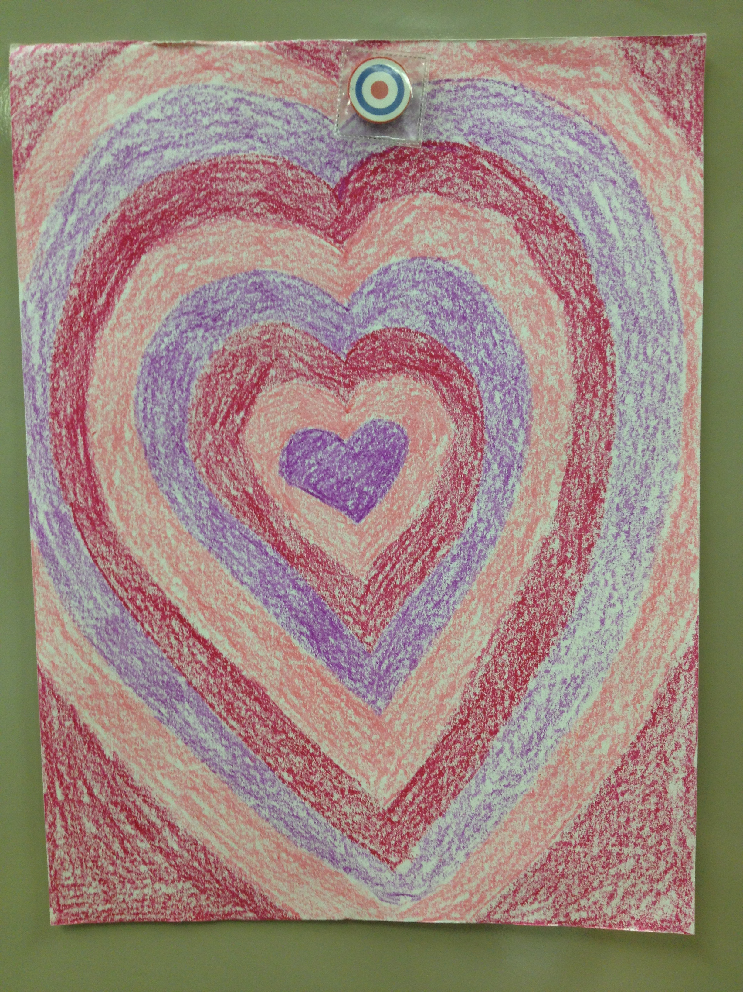
Name___________________Lesson______________________
Assessment
Thumbs Down | Don’t Know | Thumbs Up | Assessment Question
 |  |  | Did you use your personal best during this lesson?
 |  |  | Did you actively listen and follow directions?
 |  |  | Did you use your creativity? (is it original?)
 |  |  | Did you complete your project?
 |  |  | Did you incorporate the art media?
 |  |  | Does the artwork show the elements and/or principles discussed?
Source

