BPS Elementary Art Curriculum

The Deep Blue Sea Crayon Resist
Pic ture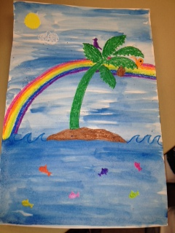
Content Connections:
Reading: The story “The Deep Blue Sea” by Audrey Wood and Bruce Wood w/ the Scott Foresman story Life in the Ocean

Art Standards: working with art tools and techniques

Materials: crayons, watercolors, and white paper

Art Elements | Art Principles
_X_Line | __Pattern
X_Shape/Form | X _Rhythm/movement
X_Color | X Proportion/Scale
X_Value | __Balance
__Texture | __Unity
X_Space/Perspective | X_Emphasis

Grade: Kindergarten
Time: 45 minutes to 1 hour
Lesson
- Read the stories Life in the Ocean (Scott Foresman) and The Deep Blue Sea by Audrey Wood and Bruce Wood
- Hand each student a 12 x 18 piece of white paper
- Each student will take out their set of crayons
- Have students give a recall of how the story happens
- As they recall each event, take a moment for each student to draw that item on their paper
  - For example:” in the deep blue sea there was a rock”-students would draw the waves for the sea and the grey rock
- Once you have drawn each event throughout the story, each table will need a small cup of water and each child will need a set of watercolors
- Then each child will use the blue watercolor to go over their picture they’ve drawn with crayons, to make a crayon resist picture.

Preparation: large white sheets of paper, crayons for each child, watercolors for each child
Vocabulary: all color words, all positional words, sequence

I Cans follow directions and use multiple art techniques such as: painting, drawing, etc.

Teacher Background Knowledge
Knowing what crayon resist is and how to accomplish this technique

Name___________________Lesson______________________
Assessment
Thumbs Down | Don’t Know | Thumbs Up | Assessment Question
 |  |  | Did you use your personal best during this lesson?
 |  |  | Did you actively listen and follow directions?
 |  |  | Did you use your creativity? (is it original?)
 |  |  | Did you complete your project?
 |  |  | Did you incorporate the art media?
 |  |  | Does the artwork show the elements and/or principles discussed?

