**BPS Elementary Art Curriculum**

Line Art

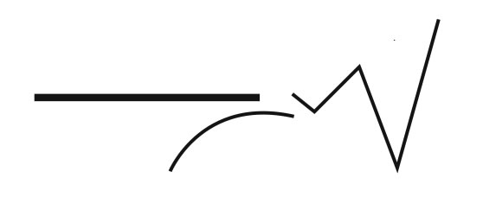

Content Connections:

Math – Patterns

Handwriting – hand grip/motor skills

4.5.2 Students examine the artistic expression of such common themes as childhood,

peace, or celebrations in works of art representing different cultures

.4.1.2 Know the different techniques* used to create* visual art.

4.1.6 Use visual art materials and tools* in a safe and responsible manner.

Materials:

Paper (with or without lines), crayons, water color paint, paint brushes, and cups of water

|  |  |
| --- | --- |
| **Art Elements** | **Art Principles** |
| _x_Line | _x_Pattern |
| __Shape/Form | __Rhythm/movement |
| x__Color | __Proportion/Scale |
| __Value | __Balance |
| _x_Texture | __Unity |
| __Space/Perspective | __Emphasis |

Grade: Kindergarten

Time: 30 minutes

Preparation

Have a paper (with or without lines already started) for each student. Also have water color and water to paint with ready. You may also want to have an example to show the students.

Vocabulary:

I Cans

I can

Lesson description:

Teacher Background Knowledge

Line, Color, Paint

Lesson

First talk with the students about lines and that lines can be curvy, straight, squiggly, etc… Then show them how to either make their own lines or trace the lines provided with crayon. Have students then make their own lines. After they complete this they can water color over the lines and see how the paint does not adhere to the crayon. You can have the students make a pattern with the paint or just let them have a free choice in their color selection.

Name___________________Lesson______________________

*Assessment*

|  |  |  |  |
| --- | --- | --- | --- |
| **Thumbs Down** | **Don’t Know** | **Thumbs Up** | **Assessment Question** |
|  |  |  | Did you use your personal best during this lesson? |
|  |  |  | Did you actively listen and follow directions? |
|  |  |  | Did you use your creativity? (is it original?) |
|  |  |  | Did you complete your project? |
|  |  |  | Did you incorporate the art media? |
|  |  |  | Does the artwork show the elements and/or principles discussed? |
|  |  |  |  |
|  |  |  |  |
|  |  |  |  |

Source