**BPS Elementary Art Curriculum**

Arlo Needs Glasses

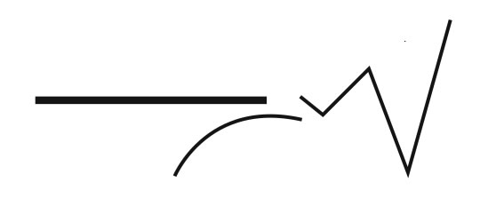

Content Connections: Read the book Arlo needs glasses, (found out at the Mandan Public Library).

-Language Arts Connection: RL.1.2.-discuss book characters, setting, plot.

Art Standards:,1.g.02, 1.g.03

Alignment Standards: Language Arts RL1.2

Materials: paper, oil pastels, materials for the glasses.

|  |  |
| --- | --- |
| **Art Elements** | **Art Principles** |
| _x_Line | __Pattern |
| _x_Shape/Form | __Rhythm/movement |
| __Color | __Proportion/Scale |
| __Value | __Balance |
| __Texture | __Unity |
| _x_Space/Perspective | __Emphasis |

Grade: First

Time: 50 minutes

Preparation: gather materials, and precut glasses template if you are planning on not letting students do them on their own.

Vocabulary: symmetrical-a word to use for making the glasses and Arlo.

I Cans : I can draw shapes.

I can draw shapes that are symmetrical.

Lesson description: Students will use oil pastels to create the character in the book.

Teacher Background Knowledge:

Lesson : [www.deepspacesparkle.com/2013/01/03/arlo-needs-glasses-art-lesson/#sthash.9C8g9Q3F.dpuf](http://www.deepspacesparkle.com/2013/01/03/arlo-needs-glasses-art-lesson/#sthash.9C8g9Q3F.dpuf)

-Read the book Arlo needs glasses, discuss characters, setting, beginning, middle and end.

-demonstrate how to make Arlo using shapes and line.

-after drawing Arlo students will use oil pastels to color in Arlo and then use black oil pastel to outline Arlo.

-After coloring in Arlo and a background allow students to create symmetrical glasses by folding a piece of paper in half and measuring how big you will need Arlo’s glasses.

-Let students use their personal creativity to decorate Arlo’s glasses.

Name___________________Lesson______________________

*Assessment*

|  |  |  |  |
| --- | --- | --- | --- |
| **Thumbs Down** | **Don’t Know** | **Thumbs Up** | **Assessment Question** |
|  |  |  | Did you use your personal best during this lesson? |
|  |  |  | Did you actively listen and follow directions? |
|  |  |  | Did you use your creativity? (is it original?) |
|  |  |  | Did you complete your project? |
|  |  |  | Did you incorporate the art media? |
|  |  |  | Does the artwork show the elements and/or principles discussed? |
|  |  |  |  |
|  |  |  |  |
|  |  |  |  |

Source: www.deepspacesparkle.com