**BPS Elementary Art Curriculum**

Title

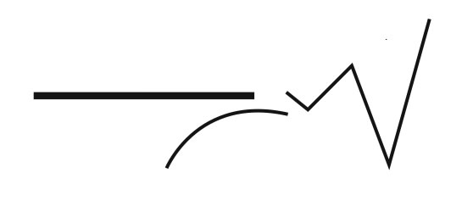

Art Standards: 4.1.5 know how different visual/art media, techniques, and processes to communicate ideas, experiences, and stories.

Content Connections:

First Grade Scotts Foresman: The Big Blue Ox

Materials: S.F. story The Big Blue Ox Egg cartons for paint, Paint brushes, paint, white and brown construction paper, google eyes, horn pattern, variety of construction paper colors, black crayons, glue

|  |  |
| --- | --- |
| **Art Elements** | **Art Principles** |
| __Line | _x_Pattern |
| _x_Shape/Form | __Rhythm/movement |
| _x_Color | _x_Proportion/Scale |
| __Value | __Balance |
| __Texture | __Unity |
| _x_Space/Perspective | __Emphasis |

Grade: First

Time: 45 minutes

Preparation

Have the children read story, The Big Blue Ox, in their S.F. book.

Gather Material

Have horn tracers ready for students to trace.

Vocabulary: imagination, design, inspiration,

George Rodrigue

I Cans:

I can contrast colors

I can draw an object

Lesson description:

Do a directed line drawing of an OX. Use George Rodrigue Art examples as a guideline for the art project. Allow students to use their imagination to paint ox and add designs to background.

Teacher Background Knowledge

Teacher will need to know a bit about George Rodrigue’s Art.

Lesson

1. Read the story The Big Blue Ox
2. Review with the students the information you have learned about from the art of George Rodrigue
3. Pass out 9x12 white construction paper to each student
4. Do a directed line drawing using black crayon to draw the ox
5. Have students choose paint colors to paint body of ox
6. Have students choose paint colors to paint background
7. While paint is drying trace two horns on brown construction paper
8. Paste horns and googly eyes onto ox

Name___________________Lesson______________________

*Assessment*

|  |  |  |  |
| --- | --- | --- | --- |
| **Thumbs Down** | **Don’t Know** | **Thumbs Up** | **Assessment Question** |
|  |  |  | Did you use your personal best during this lesson? |
|  |  |  | Did you actively listen and follow directions? |
|  |  |  | Did you use your creativity? (is it original?) |
|  |  |  | Did you complete your project? |
|  |  |  | Did you incorporate the art media? |
|  |  |  | Does the artwork show the elements and/or principles discussed? |
|  |  |  |  |
|  |  |  |  |
|  |  |  |  |

Source