Content Connections:
Informational Writing
Seasons

Roosevelt Elementary SALT Integrated Lesson Plan

Bears
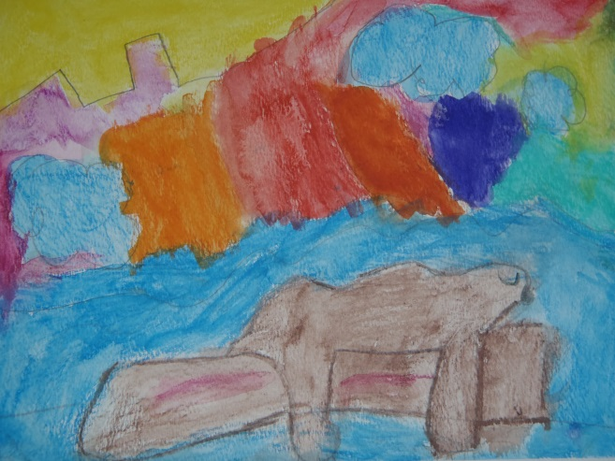
Artists Habits of Mind
☒ Develop Craft
☒ Engage & Persist
☐ Envision
☐ Express
☐ Observe
☐ Reflect
☐ Stretch & Explore
☐ Understand the Art World

Art Standards: 4.1.5 Know how different visual art media, techniques, and processes are used to communicate ideas, experience, and stories.
Alignment Standards: Writing – W.1.2 Write informative/explanatory texts in which they name a topic, supply some facts about the topic, and provide some sense of closure.

Materials: PowerPoint of bears and different seasons, watercolor paper, blue painter’s tape, drawing paper, watercolor pencils, flat paintbrushes, round paintbrushes.

21st Century Skills
☐ Global Awareness
☒ Creativity and Innovation
☐ Critical Thinking and Problem
Solving

☐ Communication and Collaboration

☐ ICT Literacy

☐ Flexibility and Adaptability
☐ Initiative and Self-Direction
☐ Productivity and Accountability

☐ Understand the Art World

Art Elements | Art Principles
_x_Line | __Pattern
_x_Shape/Form | __Rhythm/movement
__Color | _x_Proportion/Scale
__Value | __Balance
__Texture | __Unity
__Space/Perspective | __Emphasis

Grade: 1st Grade
Time: 1 ½ - 2 hours
Preparation:
Make a PowerPoint with pictures of the different seasons and bears.
Gather materials.
Use blue painter’s tape to make a frame around the edge of the watercolor paper and to adhere the paper to the table for each student.
Vocabulary:
composition, horizon, wet on wet, background, texture, blend, proportion

I Cans
I can write a topic.
I can write some facts about a topic.
I can provide closure to my writing piece.
Lesson:
- Discuss with the children the seasons. Look at the PowerPoint of the seasons. What do you notice about the colors?
- Look at a PowerPoint of bears during the different seasons. What are the bears doing? (Show pictures of hibernating, eating berries, bear cubs, bears fishing, etc.)
- Take a closer look at a bear. What colors do you notice? You can blend different browns together to get different colors. If you touch a bear, how would it feel? What is the word to describe how something feels? (Texture). What sizes do you notice?
- Let’s look at the shapes we see in a bear. What shape do you see in the body? What shapes do you see in the head, ears, legs, etc.? As the children mention the shapes, draw a bear on the board and describe how you are using the shapes. (Circle, semi-circle, oval, triangle, etc.)
- Let’s look at proportion. What is the biggest part going to be? Notice the size of his legs, eyes, ears, tail. Will they be bigger or smaller?
- How could we add texture to our bear? (Points, lines, dots, squiggles, etc.) Let’s look at the bear’s fur again. Notice how the fur goes in different directions.
- Hand out drawing paper and let the students practice drawing bears.
- Now let’s talk about bears in different seasons. What are some things you might see them do? What is around them? What is going on in the background? Think about a season that you would like to use for your painting.
- Have children draw a bear on their watercolor paper. Notice how he appears to be floating. Let’s add something that a bear would typically do during the season that you thought of. Draw the ground and show the horizon. Add details. What time of day is it? What shapes will you use?
- Demonstrate watercolor pencils. On a small piece of watercolor paper, draw a shape or simple thing, coloring it in, and then using the water and brush to blend it. Draw the same thing again and carelessly smear water on it to illustrate how you still have to “paint” what you’ve drawn, not just randomly add water. Demonstrate wetting the paper and drawing on the wet paper (wet on wet) with watercolor pencils. Talk about how they will also be able to show the seasons by the colors that they use.
- Have children color their pictures with the watercolor pencils.
- Using water, children “paint” where the watercolor pencils have been used.
- Continue to walk around and check in with them as they are working.
- When the pictures are dry, remove the blue painter’s tape.
- Have the children write about their bear and what it would be doing during the season they have illustrated.

Lesson description:
Students will take what they are learning about bears and the seasons and use that in their art by drawing a scene of a bear/bears, a seasonal activity of their choice, and the habitat using watercolor pencils.
Teacher Background Knowledge:
Teachers will need to have an understanding of watercolor techniques.
Teacher will need to have some knowledge about bears during the different seasons.
Name___________________Lesson______________________
Assessment
Thumbs Down | Don’t Know | Thumbs Up | Assessment Question
 |  |  | Did you use your personal best during this lesson?
 |  |  | Did you actively listen and follow directions?
 |  |  | Did you use your creativity? (is it original?)
 |  |  | Did you complete your project?
 |  |  | Did you incorporate the art media?
 |  |  | Does the artwork show the elements and/or principles discussed?
Source

