BPS Elementary Art Curriculum

Beautiful Oops
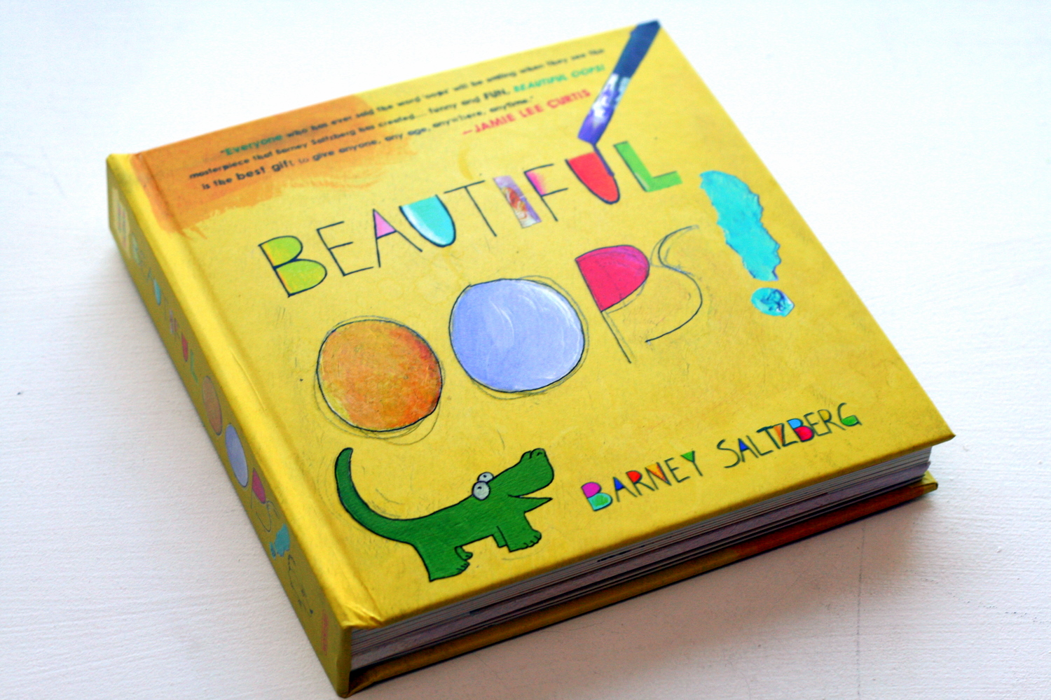
Content Connections:
Reading

Art Standards:

Materials:
Garbage
The book “Beautiful Oops”

Art Elements | Art Principles
_x_Line | __Pattern
_x_Shape/Form | __Rhythm/movement
__Color | _x_Proportion/Scale
__Value | __Balance
_x_Texture | __Unity
_x_Space/Perspective | _x_Emphasis

Grade: 1
Time: 1 session
Preparation:

Lesson
Read the book “Beautiful Oops”

Demonstrate an Oops

Vocabulary:

I Cans
Create art

Teacher Background Knowledge
http://www.youtube.com/watch?v=2fZjMYdQjGM

http://www.youtube.com/watch?v=gC6fF5IJjjU

Name___________________Lesson______________________
Assessment
Thumbs Down | Don’t Know | Thumbs Up | Assessment Question
 |  |  | Did you use your personal best during this lesson?
 |  |  | Did you actively listen and follow directions?
 |  |  | Did you use your creativity? (is it original?)
 |  |  | Did you complete your project?
 |  |  | Did you incorporate the art media?
 |  |  | Does the artwork show the elements and/or principles discussed?

