Content Connections:
Informational Writing

Roosevelt Elementary SALT Integrated Lesson Plan

Bees
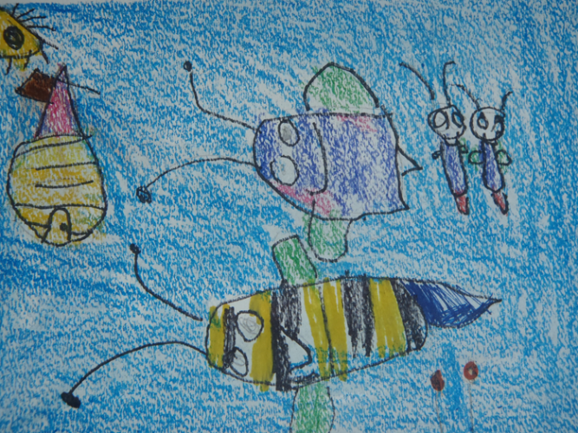
Artists Habits of Mind
☒ Develop Craft
☒ Engage & Persist
☐ Envision
☐ Express
☐ Observe
☐ Reflect
☐ Stretch & Explore
☐ Understand the Art World

Art Standards: 4.1.5 Know how different visual art media, techniques, and processes are used to communicate ideas, experience, and stories.
Alignment Standards: Writing – W.1.2 Write informative/explanatory texts in which they name a topic, supply some facts about the topic, and provide some sense of closure.

Materials: Watercolor paper, blue painter’s tape, drawing paper, set of watercolor paints, flat paintbrushes, round paintbrushes, paper towels, crayons, Sharpies.

21st Century Skills
☐ Global Awareness
☒ Creativity and Innovation
☐ Critical Thinking and Problem
Solving

☐ Communication and Collaboration

☐ ICT Literacy

☐ Flexibility and Adaptability
☐ Initiative and Self-Direction
☐ Productivity and Accountability

☐ Understand the Art World

Art Elements | Art Principles
_x_Line | __Pattern
_x_Shape/Form | __Rhythm/movement
__Color | _x_Proportion/Scale
__Value | __Balance
__Texture | __Unity
__Space/Perspective | __Emphasis

Grade: 1st Grade
Time: 1 ½ - 2 hours
Preparation:
Use blue painter’s tape to make a frame around the edge of the watercolor paper and to adhere the paper to the table for each student.
Vocabulary:
composition, horizon, wet on wet, texture, lift technique, crayon resist

I Cans
I can write a topic.
I can write some facts about a topic.
I can provide closure to my writing piece.

Lesson description:
Students use their knowledge of bees to help them as they learn how to use shapes to draw bees and their environment.
Teacher Background Knowledge:
Teachers will need to have an understanding of brush and watercolor techniques.
Teachers will need to understand a bee’s environment and habitat.
Lesson:
- Review with the class the information they have learned about bees. What are the parts of a bee? What shapes do you think would work well to draw these? What kind of things do bees do and what are their jobs?
- Draw different bees on the board showing how simple shapes can be put together to create drawings of bees doing different things.
- Pass out drawing papers and have students practice sketching bees.
- Talk with the class about the different places you might find bees. Draw these background elements on the board to create a composition. Introduce the word composition. The word “compose” means to arrange. What does a composer do? Arranges music. The word “composition” means how a picture is arranged.
- Have students think about their “compositions”. Where is their bee? What is their bee doing?
- Have students begin drawing out their composition. Emphasize using the space and drawing bigger.
- Demonstrate adding color to bees and surroundings. Stress that the sky/ or large background should be left blank for the watercolor.
- Have students begin to add color to their bees and surroundings using Sharpies and crayons. Pass out containers of water, watercolors, paper towels, flat, and round brushes.
- Demonstrate wet on wet for the students. Show them the lift technique using a paper towel or Kleenex to make clouds. Also introduce crayon resist at this time.
- Have students add watercolor to their images and background areas.
- Let dry and remove the painter’s tape.
- Have students write informational text about bees.
- Reflect on the activity.

Name___________________Lesson______________________
Assessment
Thumbs Down | Don’t Know | Thumbs Up | Assessment Question
 |  |  | Did you use your personal best during this lesson?
 |  |  | Did you actively listen and follow directions?
 |  |  | Did you use your creativity? (is it original?)
 |  |  | Did you complete your project?
 |  |  | Did you incorporate the art media?
 |  |  | Does the artwork show the elements and/or principles discussed?
Source

