Butterfly Symmetry
Demographics
Title of the lesson: Butterfly Symmetry
Grade Level: 1st
Main Subject: Art
Subjects Integrated: Math
Time Required: 45 min.

Standards and Benchmarks:

Art: 4.1.2 Know the different techniques* used to create* visual art.

Math:

CCSS.Math.Content.1.G.A.3 Partition circles and rectangles into two and four equal shares, describe the shares using the words halves, fourths, and quarters, and use the phrases half of, fourth of, and quarter of. Describe the whole as two of, or four of the shares. Understand for these examples that decomposing into more equal shares creates smaller shares.

CCSS.Math.Content.4.G.A.3 Recognize a line of symmetry for a two-dimensional figure as a line across the figure such that the figure can be folded along the line into matching parts. Identify line-symmetric figures and draw lines of symmetry.

“I can” Objectives:
- I can use paint techniques to create artistic patterns.
- I can use symmetry to create a butterfly

Materials needed:
- Cardstock or white construction paper
- tempera paints
- pipe cleaners(optional) or use a black marker
- scissors
- paper towels
- different colors of construction paper

Prep Work:
- Gather the materials
- Make example

Anticipatory Set:

Procedures / Instructional Strategies:
- First, fold the cardstock in half
- Using the tempera paints, splatter drops of paint onto one side of the cardstock.

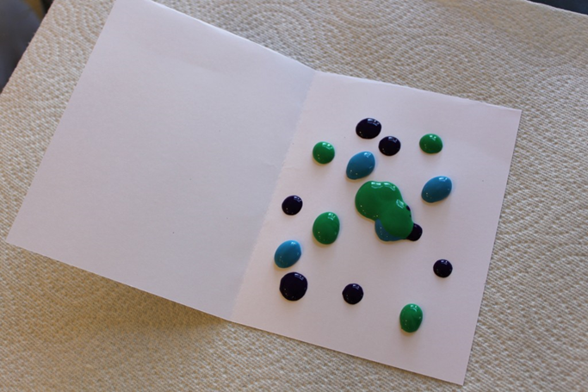
- Refold the cardstock and press it so that the paint inside the cardstock spreads.

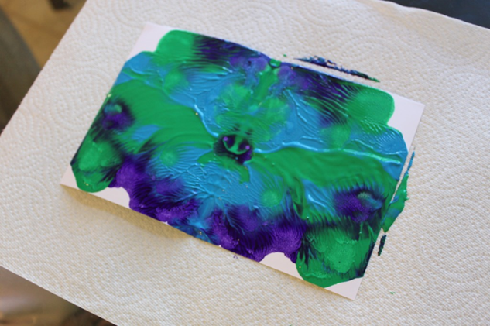
- Open the cardstock and admire your symmetrical design.

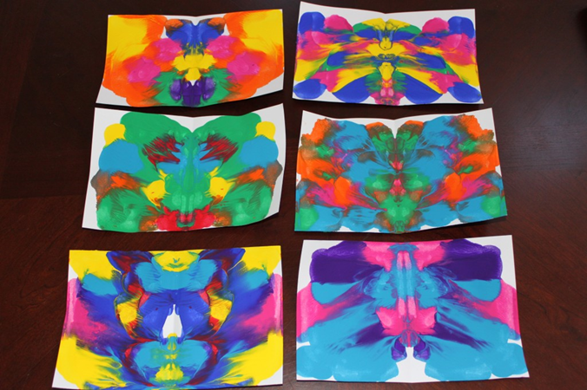

- Allow the paint to dry.
- Once the paint is dry, refold the cardstock and cut a butterfly shape. Open the cardstock and enjoy your bright, beautiful butterfly!

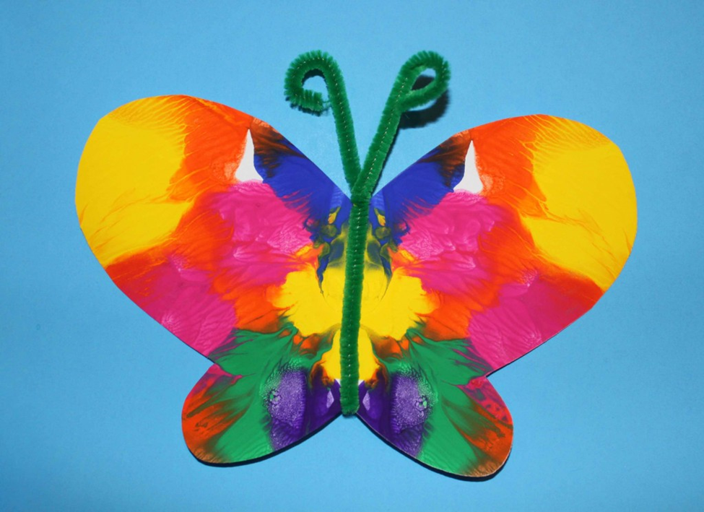
- Lastly, paste your butterfly onto construction paper and add the antennas. Have a gallery walk and have the students complement one another or simply hang them up in the hall.

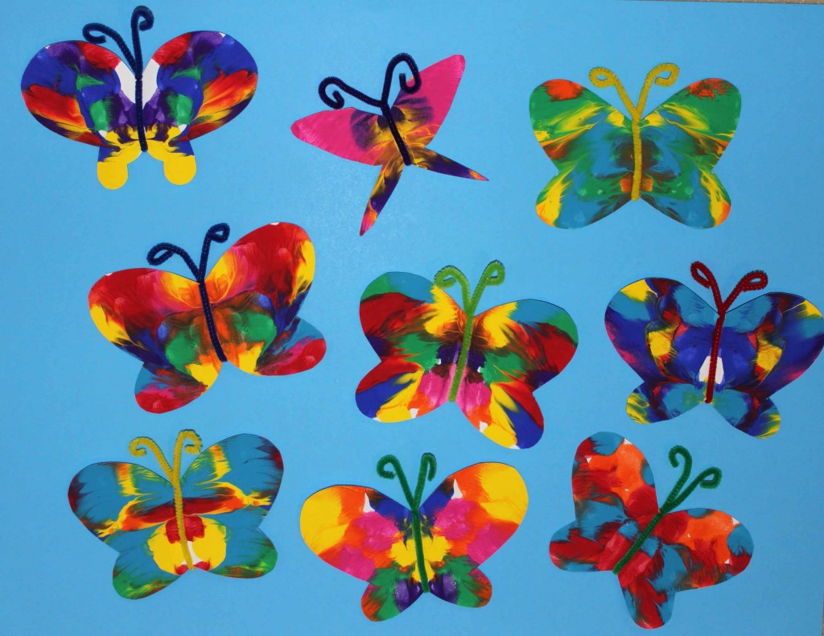

Discussion Questions:

Assessments:
- Checklist for project:
Butterfly Symmetry | yes | no

Symmetry was understood in creating the butterfly

Finished the butterfly and used the correct technique.

Closure: take 5 minutes to do a gallery walk and admire everyone’s artwork

