Content Connections:
Informational Writing
Scott Foresman 1st grade story Tippy-Toe, Chick Go

Roosevelt Elementary SALT Integrated Lesson Plan

Chicks
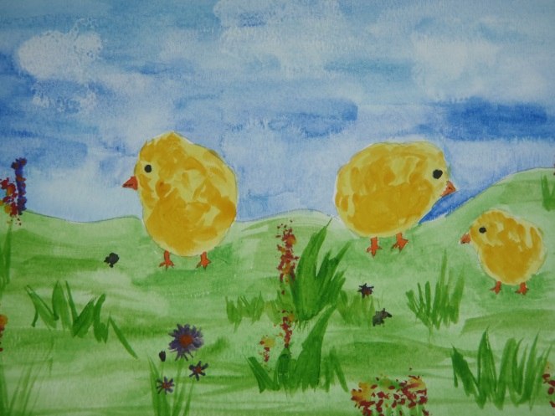
Artists Habits of Mind
☒ Develop Craft
☒ Engage & Persist
☐ Envision
☐ Express
☐ Observe
☐ Reflect
☐ Stretch & Explore
☐ Understand the Art World

Art Standards: 4.1.5 Know how different visual art media, techniques, and processes are used to communicate ideas, experience, and stories.
Alignment Standards: Writing – W.1.2 Write informative/explanatory texts in which they name a topic, supply some facts about the topic, and provide some sense of closure.

Materials: S.F. story Tippy-Toe, Chick Go, Watercolor paper, blue painter’s tape, drawing paper, watercolor paints, flat paintbrushes, round paintbrushes, paper towel, Sharpies.

21st Century Skills
☐ Global Awareness
☒ Creativity and Innovation
☐ Critical Thinking and Problem
Solving

☐ Communication and Collaboration

☐ ICT Literacy

☐ Flexibility and Adaptability
☐ Initiative and Self-Direction
☐ Productivity and Accountability

☐ Understand the Art World

Art Elements | Art Principles
_x_Line | __Pattern
_x_Shape/Form | __Rhythm/movement
__Color | _x_Proportion/Scale
__Value | __Balance
__Texture | __Unity
__Space/Perspective | __Emphasis

Grade: 1st Grade
Time: 1 ½ - 2 hours
Preparation:
Have children read story, Tippy-Toe, Chick Go, in their S.F. book.
Gather materials.
Use blue painter’s tape to make a frame around the edge of the watercolor paper and to adhere the paper to the table for each student.
Vocabulary:
composition, horizon, wet on wet, background, texture, proportion, environment

I Cans
I can write a topic.
I can write some facts about a topic.
I can provide closure to my writing piece.
Lesson:
- Review with the class the information they have learned about chicks. What are the parts of a chick? What shapes do you think would work well to draw these? What kind of things do chicks do and what is their environment?
- Draw different chicks on the board showing how simple shapes can be put together to create drawings of chicks doing different things.
- Pass out drawing papers and have students practice sketching chicks.
- Talk with the class about the different places you might find chicks. Draw these background elements on the board to create a composition.
- Have students think about their “compositions”. Where is/are their chick/chicks? What is their chick doing?
- Have students begin drawing out their composition on watercolor paper. Emphasize using the space and drawing bigger. The chicks are the “star” of the composition.
- Demonstrate adding color to chicks and surroundings. Talk about the horizon and have the children add it to their composition. Stress that the sky/ or large background should be left blank for the watercolor.
- Have students begin to add color to their chicks’ feet, eyes, beaks and smaller details in the surroundings using colored Sharpies. Pass out containers of water, watercolors, paper towels, flat, and round brushes.
- Demonstrate wet on wet for the students. Show them the lift technique using a paper towel or Kleenex to make clouds.
- Have students add watercolor to their images and background areas.
- Let dry and remove the painter’s tape.
- Have students write informational text about chicks.
- Reflect on the activity.

Lesson description:
Students will use their knowledge of chicks to help them as they learn how to use shapes to draw chicks and their environment.
Teacher Background Knowledge:
Teachers will need to have an understanding of watercolor techniques.
Teacher will need to have some knowledge about chicks.
Name___________________Lesson______________________
Assessment
Thumbs Down | Don’t Know | Thumbs Up | Assessment Question
 |  |  | Did you use your personal best during this lesson?
 |  |  | Did you actively listen and follow directions?
 |  |  | Did you use your creativity? (is it original?)
 |  |  | Did you complete your project?
 |  |  | Did you incorporate the art media?
 |  |  | Does the artwork show the elements and/or principles discussed?
Source

