BPS Elementary Art Curriculum

Expand an Animal
Picture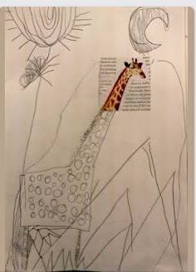
Content Connections:
Reading for Information
Informative Writing

Art Standards:
1.2.1
1.5.1

Materials:
Animal heads or bodies that are cut out of magazines, white construction paper, pencil, crayons

Art Elements | Art Principles
__Line | __Pattern
__Shape/Form | __Rhythm/movement
_X_Color | _X_Proportion/Scale
__Value | __Balance
__Texture | _X_Unity
_X_Space/Perspective | __Emphasis

Grade: First
Time: 45 minutes
Lesson
- Students wrote informative stories about an animal that they researched.
- Find the animal in a magazine and cut out one part- the head or the body
- Glue the picture onto white construction paper
- Use a pencil to continue the picture, trying to make everything the correct proportions
- Color the picture

Preparation: Gather materials
Vocabulary:

I Cans
I can expand an image.
I can write facts about an animal.

Teacher Background Knowledge
Informational Writing Rubric
Name___________________Lesson______________________
Assessment
Thumbs Down | Don’t Know | Thumbs Up | Assessment Question
 |  |  | Did you use your personal best during this lesson?
 |  |  | Did you actively listen and follow directions?
 |  |  | Did you use your creativity? (is it original?)
 |  |  | Did you complete your project?
 |  |  | Did you incorporate the art media?
 |  |  | Does the artwork show the elements and/or principles discussed?

