BPS Elementary Art Curriculum

Flower Parts
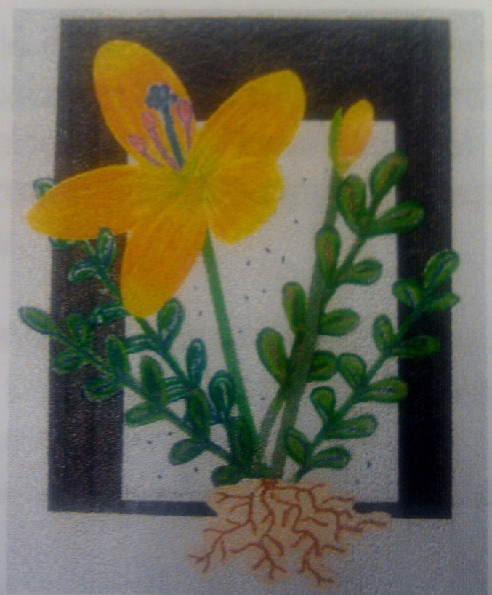
Materials: Students receive construction paper as follows:
one each of:
9”x12” black, 6”x9” gray, 6”x9” white, 4”x3” peach or salmon
many pieces of: 3”x9” various green shades
¼”x9” various green shades - Oil pastels Scissors, glue
Art Standards: 4.1.1, 4.1.2, 4.1.3, 4.1.4, 4.1.5, 4.1.6, 4.2.1, 4.2.2, 4.2.3, 4.3.1, 4.5.1, 4.5.2, 4.6.2
Alignment Standards: ND Science Standards
1.4.1, 1.4.2
Content Connections:
Life Science
THEMES: Our World --Nature

Art Elements | Art Principles
_x Line | _x_Pattern
_x_Shape/Form | __Rhythm/movement
_x_Color | _x_Proportion/Scale
__Value | __Balance
_x_Texture | __Unity
__Space/Perspective | __Emphasis

Grade: 1st
Time: 1-2 Sessions
Preparation:
1. Create a color wheel with the primary and secondary colors.
(see enclosed color wheel sheet for student use)
Vocabulary: Shape, color wheel, contour line, 3-D relief flower parts: petal, bud, stamen, stigma, stems, leaves, and roots

Lesson:
1. Glue the 6”x9” gray to the 9”x12” black with 6 dots of glue.
2. Choose three analogous colors, on the color wheel that you created.
3. Choose a petal shape, on the white paper, use your lightest of the three analogous colors to draw four large and one smaller petal for the front. Then shade it in thirds with the other analogous colors moving in a vertical direction. (The vertical direction of coloring makes the flower look real because that is the way the petal gets nutrients.) When the petal is filled with color draw white vertical lines in the middle of the colored petal. Next, blend colors with your finger by pushing in one direction only. If you rub back and forth, the colors have a muddy look.
4. Draw the stamen and stigma on the same white paper. These are the reproducing parts of the flower. Now use the opposite colors on the color wheel so the petals will not camouflage the stamen and stigma. For example, look at the three analogous colors of your petals and choose oil pastels from the opposite colors on the wheel for the stamen and stigma.
5. Add a small flower bud in the corner of the same white paper. Then cut out all the pieces.
6. Look at the four leaf information boards. Choose a leaf shape. Pick light and dark green oil pastels and two other colors analogous to green. Draw four large leaves, two on each green paper, and add the veins. Use all three analogous colors to fill in the color. Cut out the leaves.
7. Draw the roots next. This part is under the ground, but is an important part of the flower. Draw these on a salmon color paper and cut out with an interesting contour line cut. A contour line follows along the outside of a shape. Sometimes it is referred to as a “bubble cut.
8. Fold the flower petals, and roots so they push out from the flat surface. Fold in half and then pull back the edges to make an airplane type fold.
9. ARRANGEMENT AND GLUING:
Use this order for easy assembly.
I Cans/ Objectives:
1. I can name the parts of a flower.
2. I can identify the primary and secondary colors on the color wheel.
3. I can use crayons for drawing, blending, and shading techniques.
4. I can make 3-D shapes by folding paper.
Lesson description: The parts of flowers are discussed. Students then use crayons and shading techniques to create flower parts and assemble these parts to make a flower relief.
Teacher Background Knowledge:
Knowledge relating to the parts of the flowers. Teacher will also have knowledge of how to use crayons and how to create 3-D folding of paper to create a relief. Teachers will also need to know that analogous color are those that next each other on the color wheel. Flower petals often appear to be only one color, but artists like to use the touching (analogous) colors to make the flowers more interesting.

Name___________________Lesson______________________
Assessment
Thumbs Down | Don’t Know | Thumbs Up | Assessment Question
 |  |  | Did you use your personal best during this lesson?
 |  |  | Did you actively listen and follow directions?
 |  |  | Did you use your creativity? (is it original?)
 |  |  | Did you complete your project?
 |  |  | Did you incorporate the art media?
 |  |  | Does the artwork show the elements and/or principles discussed?
 |  |  | Can you name the parts of the flower?

