**BPS Elementary Art Curriculum**

Get the Egg! Art lesson

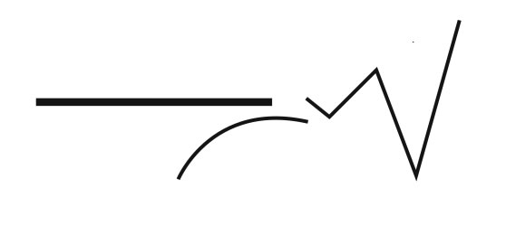

Content Connections:

Reading Street story “Get the Egg!” from Unit 1, Week 5

Art Standards: 4.1.5

Alignment Standards:

Materials:

Construction paper, oil pastels, pencils, permanent markers

|  |  |
| --- | --- |
| **Art Elements** | **Art Principles** |
| _+_Line | __Pattern |
| _+_Shape/Form | __Rhythm/movement |
| _+_Color | _+_Proportion/Scale |
| __Value | __Balance |
| __Texture | __Unity |
| _+_Space/Perspective | __Emphasis |

Grade: 1st

Time: 45 minutes

Preparation

Read “Get the Egg!”

Vocabulary:

Lines, shape, proportion, wings, beaks, legs, etc.

I Cans

I can draw a bird with many body parts.

I can use contrasting colors.

Lesson description:

Students will use their knowledge of birds to draw a bird with many body parts using a variety of lines and shapes.

Teacher Background Knowledge

Teacher will read “Get the egg!”

Teacher will prepare an example of the art project.

Teacher will practice drawing birds.

Lesson

First show students two possible options for how to draw their “birds”.

Students will draw birds on their papers using pencil.

Students will trace drawings with black permanent markers.

Students will color picture using oil pastels.

Name___________________Lesson______________________

*Assessment*

|  |  |  |  |
| --- | --- | --- | --- |
| **Thumbs Down** | **Don’t Know** | **Thumbs Up** | **Assessment Question** |
|  |  |  | Did you use your personal best during this lesson? |
|  |  |  | Did you actively listen and follow directions? |
|  |  |  | Did you use your creativity? (is it original?) |
|  |  |  | Did you complete your project? |
|  |  |  | Did you incorporate the art media? |
|  |  |  | Does the artwork show the elements and/or principles discussed? |
|  |  |  |  |
|  |  |  |  |
|  |  |  |  |

Source