**BPS Elementary Art Curriculum**

Landforms

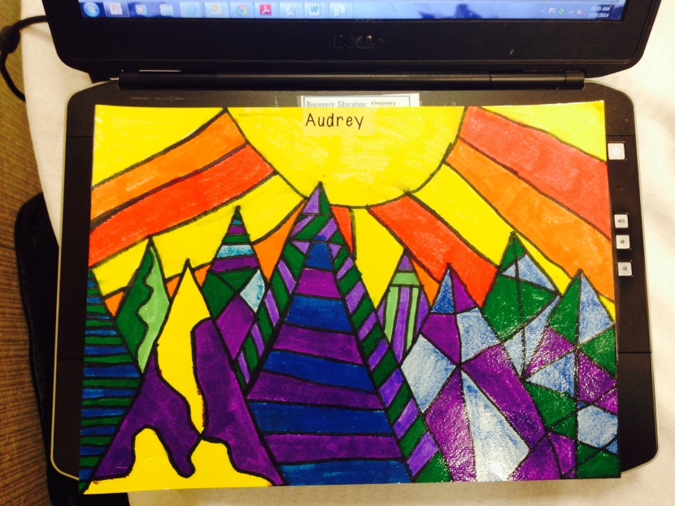

Materials: White construction paper, Warm colored markers, yellow, orange, red, Cool colored markers, purple, blue, green

Black outlining marker

Content Connections:

Social Studies Landform Unit

Art Standards: 4.1.5

Alignment Standards:

4:1.1

4.1.2

|  |  |
| --- | --- |
| **Art Elements** | **Art Principles** |
| _x_Line | __xPattern |
| _x_Shape/Form | __Rhythm/movement |
| _x_Color | _x_Proportion/Scale |
| _x_Value | _x_Balance |
| __Texture | _x_Unity |
| __xSpace/Perspective | __Emphasis |

Grade: 1

Time: 2 hours

Preparation:

Gather needed materials.

Vocabulary: warm and cold colors, horizon line, foreground, background, line, pattern, hills, mountains, rivers

I Cans

I can differentiate between warm and cool colors, I can draw various landforms,

I can differentiate between foreground and background. I can identify the horizon line

Lesson description:

Teacher Background Knowledge:

Landforms

Lesson:

We began by talking about landforms and how we could differentiate between foreground and background as well as the other shapes on our 2D picture plane. We discussed the horizon and decided that we would use cool colors for the ground and warm colors in the sky. After the horizon line was determined we broke up the land forms by breaking it up into more than one shape to create a feeling of dimension. Our next challenge was to decide how we could make one shape stand out from the other. The decision was made to fill in each new space with lines drawn in different directions. Horizontal, diagonal and vertical lines were all vocabulary words we reviewed. The students drew first with pencil on a piece of 9" X 6" drawing paper, The designs were colored in with markers. Then outlined with black markers.

Name___________________Lesson______________________

*Assessment*

|  |  |  |  |
| --- | --- | --- | --- |
| **Thumbs Down** | **Don’t Know** | **Thumbs Up** | **Assessment Question** |
|  |  |  | Did you use your personal best during this lesson? |
|  |  |  | Did you actively listen and follow directions? |
|  |  |  | Did you use your creativity? (is it original?) |
|  |  |  | Did you complete your project? |
|  |  |  | Did you incorporate the art media? |
|  |  |  | Does the artwork show the elements and/or principles discussed? |
|  |  |  |  |
|  |  |  |  |
|  |  |  |  |

Source