BPS Elementary Art Curriculum

Northern Lights and Snowy Mountains
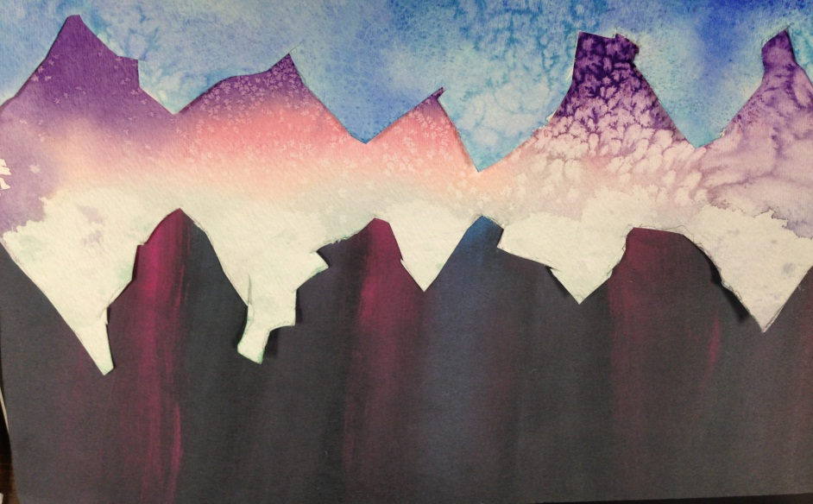
Art Standards:
4.1.2-Know the different techniques used to create visual art
4.1.3.-Know differences between visual art processes
Alignment Standards:
1.5.1-Identify Earth’s geographical landforms
Materials:
-Watercolor paper -Large paintbrush
-Watercolors -Water containers
-Salt
-Black construction paper
-Chalk or chalk pastels
-Paper Towels

Grade: 1st
Time: 1 hour
Content Connections:
-Social Studies and Landforms

Art Elements | Art Principles
_x_Line | _x_Pattern
_x_Shape/Form | __Rhythm/movement
__Color | _x_Proportion/Scale
__Value | _x_Balance
__Texture | __Unity
__Space/Perspective | __Emphasis

Vocabulary:
-Northern lights or Aurora Borealis
-Mountain ranges

Preparation
- Print examples of finished artwork and print examples of real mountain ranges.
- Print examples of student artwork and of actual mountain ranges.
- Gather the supplies.

I Cans
-I can create a mountain scene using watercolors and chalk pastels.
-I can use different techniques and materials to create my painting.
-I can show my understanding of a mountain by creating a painting.
Lesson description:
Students will create a mountain range to increase their learning of landforms with different art techniques.
Teacher Background Knowledge
-Northern lights
-Watercolor techniques
-Chalk pastels
Lesson
- First, show the students an example of a finished piece. Show them the aurora borealis in the picture and the mountain range with the salt effect.
- Explain how you are first going to cut out the mountain range out. Then you will paint the mountain and sprinkle the salt over the wet watercolor paint. As that is drying, you will then take chalk pastel and half-way up the page you will make a line of color. Then you will a paper towel and smear it upward. This will give the look of the aurora borealis.
- Explain that the Northern Lights or Aurora Borealis is a scientific reaction. That means that there are tiny itty-bitty particles in our sky, high above the earth, that are colliding with each other. The colors are caused by the different gases that are being given energy for particles from the sun. It is a complex thing that does not happen often. It is like nature fire work display and is a very special sight. It also only happens near the poles. So if you are looking at a globe, that would be the top and bottom of the globe.
- Next, show students photos of mountain ranges. Show the students how they are not just jagged. They have random curve and more natural lines. Give the students hand-outs to look at.
- After you have explained everything, tell the student to take out a pencil.
- As they are taking out a pencil, tell them that they are getting a sheet of white watercolor paper. Tell them to be patient and not to write on the paper yet.
- Then, once everyone has their page, model drawing the jagged lines. Show them how to look at the picture and then use that as a reference to draw your lines. Once your lines are drawn, then you will take out a scissor and cut out the mountain range.
- Tell the students to keep the scraps and cut out other mountains to put in front of the larger ones.
- When everyone has their pieces cut out, it is time to start painting. (MAKE SURE NAMES ARE ONE THE PIECES)
- Have each table come up and grab supplies. (you could have two sides of the room have supplies. It would go faster and not cause a cluster of many students in one area) They will need a watercolor set, a paintbrush, a water cup, and a paper towel.
- Explain that they need to wet the paper first. That allows the color to spread and blend the best. Tell them to keep most of the color towards the bottom as well. This is because a lot of mountains have snow at the top, so keep it light.
- While they are painting, put a tray in the middle of each table.
- When they have the color on have them hold their paintings above the tray and sprinkle salt on top. Have them sprinkle off the excess into the tray.
- When everyone is done, start on the black construction paper. Draw lines of color in the middle of the page with colored chalk. This does not make complete sense with words, so you will need to model this.
- Have tables come and grab a black construction paper, a packet of chalk pastels for the table, and a paper towel.
- Once they have their color on, show them how to wipe upward with the paper towel to create the Northern Lights effect.
- Set those aside and let everything dry. You may want to spray the chalk so it does not smear.
- Later, have them use a glue stick to glue the mountains on the page. Finish by naming the collage scene on the back with a title that talks about the mountain. They can even write a sentence.

Name___________________Lesson______________________
Assessment
Thumbs Down | Don’t Know | Thumbs Up | Assessment Question
 |  |  | Did you use your personal best during this lesson?
 |  |  | Did you actively listen and follow directions?
 |  |  | Did you use your creativity? (is it original?)
 |  |  | Did you complete your project?
 |  |  | Did you incorporate the art media?
 |  |  | Does the artwork show the elements and/or principles discussed?
Source: Amanda J. Anderson

