BPS Elementary Art Curriculum

Penguin Art
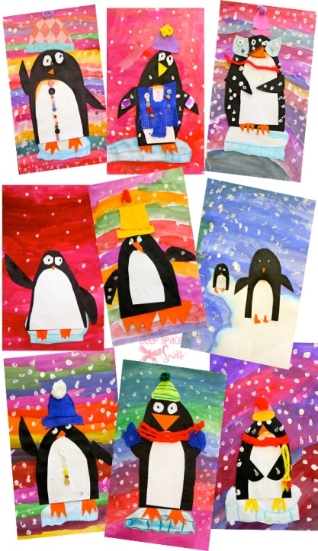
Content Connections:
Informational writing

Art Standards: 4.1.2
4.3.1
Alignment Standards:
ELA01.W.02
Materials: “12 x 18” white sulphite paper, puck tempera paint, paint brushes, cups for each color or paint, black, white, orange construction paper, crayons, scissors, glue, googly eyes (opt.), buttons, yarn

Art Elements | Art Principles
X Line | __Pattern
X Shape/Form | __Rhythm/movement
X Color | X Proportion/Scale
__Value | __Balance
X Texture | __Unity
X Space/Perspective | X Emphasis

Grade: 1
Time: two, forty-minute sessions
Preparation
Gather materials
Vocabulary: penguin, adorable, line, shape, expressive, iceberg, texture, color

I Cans
I can illustrate a penguin in its environment
I can use different elements of art in my project.

Lesson description: See link

Teacher Background Knowledge
None required
Lesson: See link below for complete lesson directions and examples
www.deepspacesparkle.com/2013/01/14/penguin-art-project/
Name___________________Lesson______________________
Assessment
Thumbs Down | Don’t Know | Thumbs Up | Assessment Question
 |  |  | Did you use your personal best during this lesson?
 |  |  | Did you actively listen and follow directions?
 |  |  | Did you use your creativity? (is it original?)
 |  |  | Did you complete your project?
 |  |  | Did you incorporate the art media?
 |  |  | Does the artwork show the elements and/or principles discussed?
Source

