BPS Elementary Art Curriculum

Shape Snowman
Picture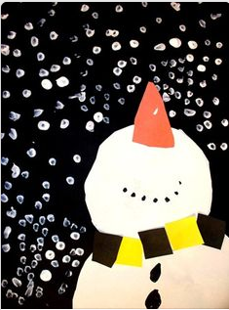
Content Connections:
Math- Shapes
Writing - Narrative

Art Standards:
1.1.2
1.2.1
Materials: Black & White construction paper, scraps of other color paper, scissors, glue, pencil, white paint

Art Elements | Art Principles
__Line | _X_Pattern
_X_Shape/Form | __Rhythm/movement
__Color | _X_Proportion/Scale
__Value | __Balance
__Texture | __Unity
_X_Space/Perspective | __Emphasis

Grade: first
Time: 40 minutes
Lesson
- Review Shapes
- Students draw- 2 circles on white paper, triangle on orange, hexagons, trapezoids, rhombus on scraps of paper, 10 little circles on black
- Cut out shapes
- Have students lay their shapes out on the black paper and try to figure out what they will make. –Give thema hine after several minutes (Snowman looking up)
- Do an example-students can replicate or create their own.
- Have them make a pattern for the scarf
- Students write about which shapes they used and how they used them.
- Students write steps of how to build a snowman
- Use pencil eraser to dab in white paint and create snow.

Preparation: Gather materials
Vocabulary:

I Cans
I can identify shapes.
I can draw shapes.
I can use shapes to make a picture.

Teacher Background Knowledge
Unit 2 Investigations
Name___________________Lesson______________________
Assessment
Thumbs Down | Don’t Know | Thumbs Up | Assessment Question
 |  |  | Did you use your personal best during this lesson?
 |  |  | Did you actively listen and follow directions?
 |  |  | Did you use your creativity? (is it original?)
 |  |  | Did you complete your project?
 |  |  | Did you incorporate the art media?
 |  |  | Does the artwork show the elements and/or principles discussed?

