BPS Elementary Art Curriculum

“The Dot” Reading Art Lesson
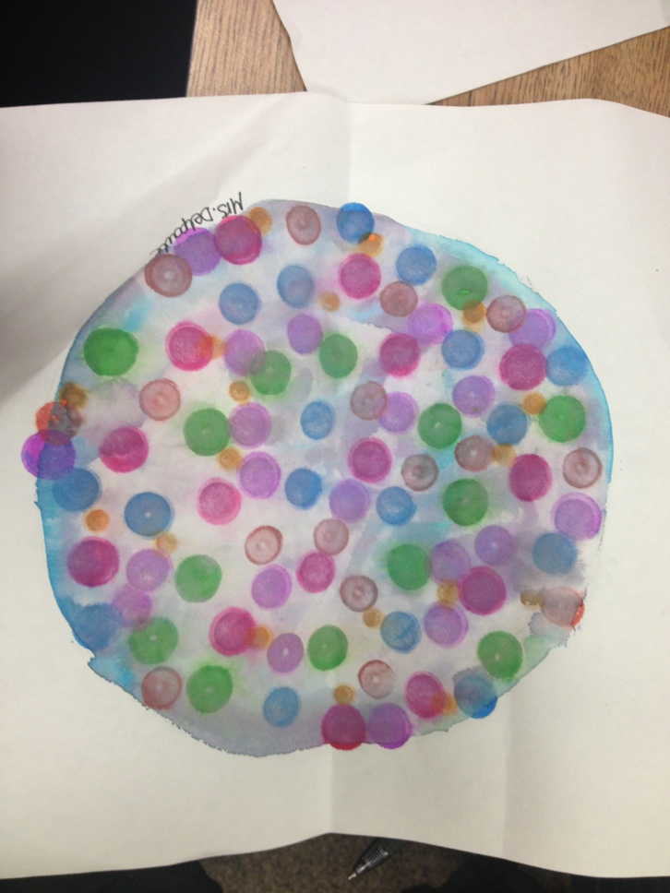
Content Connections:
This art project goes nicely with the Reading Street Unit 4.2 in First Grade. The kids use bingo dobbers and a wet wash over top. You can use water or watercolor to make it pop more.

Art Standards: 4.1.2, 4.2.1
Alignment Standards: Reading Standards
Materials:
Large White Square Paper
Bingo Dobbers
Water
Water Color

Art Elements | Art Principles
__Line | __Pattern
_x_Shape/Form | __Rhythm/movement
__Color | __Proportion/Scale
__Value | __Balance
__Texture | __Unity
_x_Space/Perspective | __Emphasis

Grade: 1
Time: 2 Days 30 min each.
Vocabulary:
Wet on Wet: Using water or paint on a wet piece of paper.
Wet on Dry: Using water or paint on a dry piece of paper.
Preparation
Prepare each child with a piece of paper that is 12 by 12. Draw a large circle on each piece of paper in pencil.
Cups of Water for each group of kids
Watercolors
Bingo Dobbers

I Cans
I can do my personal best.
I can actively listen and follow directions to either paint the inside or outside of my dot.
I can be creative using the materials given.

Teacher Background Knowledge
Read the Scott Foresman story in the Reading Street book and acknowledge that each child’s dot is different and unique and that is what makes the art project beautiful.
Lesson
Students decide if they would like to make the inside of the dot or the outside filled.
Have students lightly erase the line from where the large dot patter was traced.
Then they take the watercolors and paint either around the line or inside. The student may use one color or choose to do a few. Students have the option of letting it dry and then using the dobbers or if they would like to dob on the wet paper they can and it creates a blurry look. Or you can dob first and then paint over with water. There is not a correct way to do it because every way looks different and that is what make it fun. Look at the examples.
The colors may start to run and pool together. If this happens then use a napkin dob the extra color off.
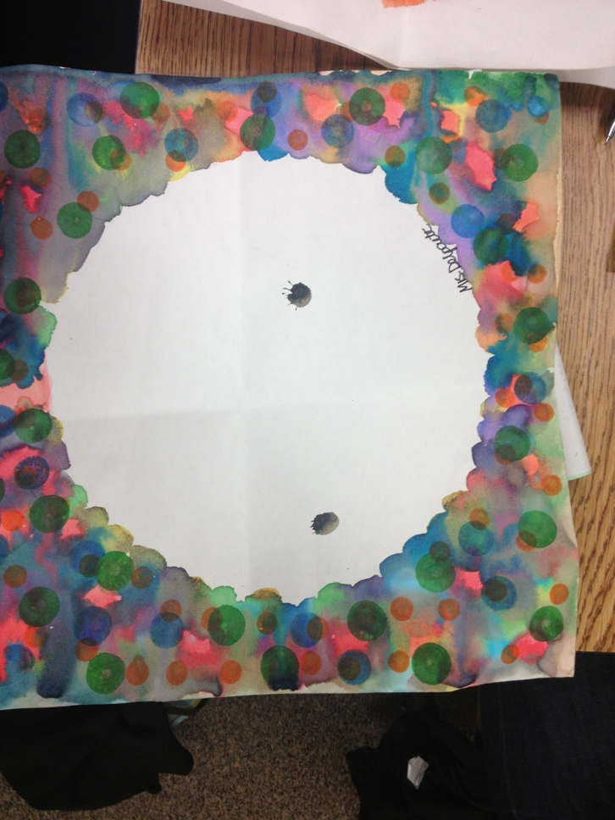
Name___________________Lesson______________________
Assessment
Thumbs Down | Don’t Know | Thumbs Up | Assessment Question
 |  |  | Did you use your personal best during this lesson?
 |  |  | Did you actively listen and follow directions?
 |  |  | Did you use your creativity? (is it original?)
 |  |  | Did you complete your project?
 |  |  | Did you incorporate the art media?
 |  |  | Does the artwork show the elements and/or principles discussed?

Source: Centennial First Grade Teachers

