BPS Elementary Art Curriculum

The Lady in the Moon
Materials: You will need:
Chinese Character Handout, Paper, Black Markers, Pencils, Scissors
Long Cut Paper *see handles and top and bottom of lanterns, Stapler and/or glue sticks
Grade: 1st
Time: 1 session
Content Connections:
Reading: The Lady in the Moon (Scott Foresman Unit 4 pages 102-117)
Social Studies
Art Standards: Standard 4: VISUAL ART* HISTORY AND CULTUREStudents understand the visual arts* in relation to history and culture.

Reading: Realistic Fiction, comprehension
Social Studies:

Art Elements | Art Principles
_x_Line | __Pattern
_x_Shape/Form | __Rhythm/movement
_x_Color | __Proportion/Scale
__Value | __Balance
_x_Texture | __Unity
__Space/Perspective | __Emphasis

Lesson
*Give students handouts with messages like peace, prosperity written in Chinese characters. Students write message in on their paper (horizontally).
*Make paper lanterns by folding these papers in 1/2 and cutting on the fold.
* Finally, with a glue stick, add top and bottom and a handle.

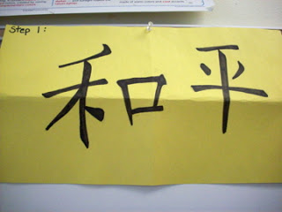

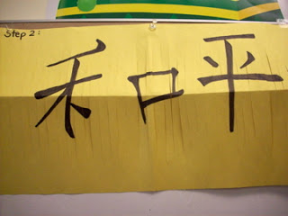

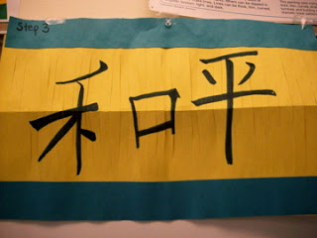

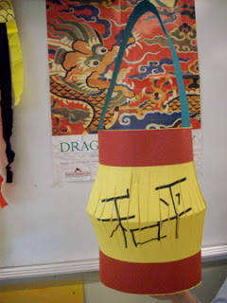

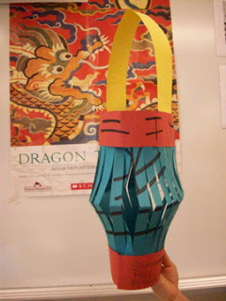

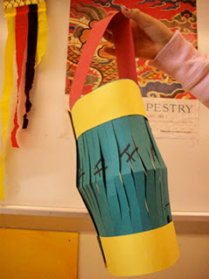

Vocabulary: lantern, above, laugh, touch, eight, moon, oh, out, does, their, our, Chinese

I Cans
I can create a Chinese lantern.
I can write in Chinese.
I can learn about Chinese culture.
Preparation
Read and discuss The Lady in the Moon by Lily Wong Fillmore in Scott Foreseman Unit 4.
Teacher Background Knowledge
The Moon Festival, also known as the Mid-Autumn Festival or the Lantern Festival, takes place each year on the fifteenth day of the eighth lunar month. This is the date of the Autumn Equinox, when the moon is at its farthest point from the earth and hence appears bright and completely round.
Traditionally the Moon Festival marks the end of the summer harvest. To the farmers of China, the festival is a celebration of thankfulness for heaven's bounty. It has been celebrated by the Chinese people since at least the first century.
Various legends are associated with moon viewing. One of the most popular concerns Chang-0, the wife of Hou-I, the Divine Archer. The legend tells of Hou-I who, having shot down nine out of ten suns that were causing havoc on earth, was rewarded by the goddess Xiwangmu with the herb of immortality. However, the beautiful and vain Chang-0 Found and ate the herb herself. Realizing that her husband would be angry, she fled to the moon where she coughed up the herb that turned into the Jade Rabbit, another mythical figure associated with immortality.
Today, children look for Chang-O and the Jade Rabbit in the shadows visible on the moon's surface. On the night of the Festival they carry paper lanterns in the shape of rabbits, phoenixes, fish and other auspicious animals. The Moon Festival is a time of gathering for family and friends, and moon cakes filled with ground lotus and sesame seeds are given as gifts.

Name___________________Lesson______________________
Assessment
Thumbs Down | Don’t Know | Thumbs Up | Assessment Question
 |  |  | Did you use your personal best during this lesson?
 |  |  | Did you actively listen and follow directions?
 |  |  | Did you use your creativity? (is it original?)
 |  |  | Did you complete your project?
 |  |  | Did you incorporate the art media?
 |  |  | Does the artwork show the elements and/or principles discussed?
 |  |  | Can you tell me what Chinese word you wrote on your lantern.

