BPS Elementary Art Curriculum

Lines
Content Connections:
Science
Insects
Symmetry

Art Standards: ART-2.2.1 Know the differences among visual art structures and functions
Alignment Standards:
SCI-2.2.1 Ask questions and seek answers about the world (e.g., Why do we have seasons?)
SCI-2.2.2 Communicate (e.g., verbal, written, graphic) observations to others.
Materials: Construction paper, scissors, glue

Art Elements | Art Principles
__Line | _x_Pattern
_x_Shape/Form | __Rhythm/movement
_x_Color | __Proportion/Scale
__Value | _x_Balance
__Texture | __Unity
__Space/Perspective | __Emphasis

Grade: 2
Time: 60 minutes
Preparation: Prepare an example of the art in advance so the children can see what the ending project. Cut smaller pieces of paper so the children are not wasteful. Have children explore books to find an example of an insect that they would like to create.
Vocabulary: Symmetry ,insect, observation, balance, pattern

I Cans:
I can communicate observations to others
I can ask questions and seek answers
I can use symmetry in art.

Lesson description:
Use symmetry to create insect art.

Teacher Background Knowledge
symmetry, balance
Lesson
1. Have children write their name on the back of their background paper.
2. Discuss symmetry with the children and how the insect’s body is always symmetrical. ( Show a few examples if the children need more help.) Discuss balance and how this is very similar to symmetry in the art piece today.
3. Demonstrate how to create an insect using symmetry. You can teach the children how to fold the paper in half if they want two pieces/sides that are exactly the same. Have the children start with pencil to draw the shapes.
4. Discuss with the students how different parts of the body look like different shapes.
5. Have the children cut out all of the shapes and pieces and then glue them on the paper.

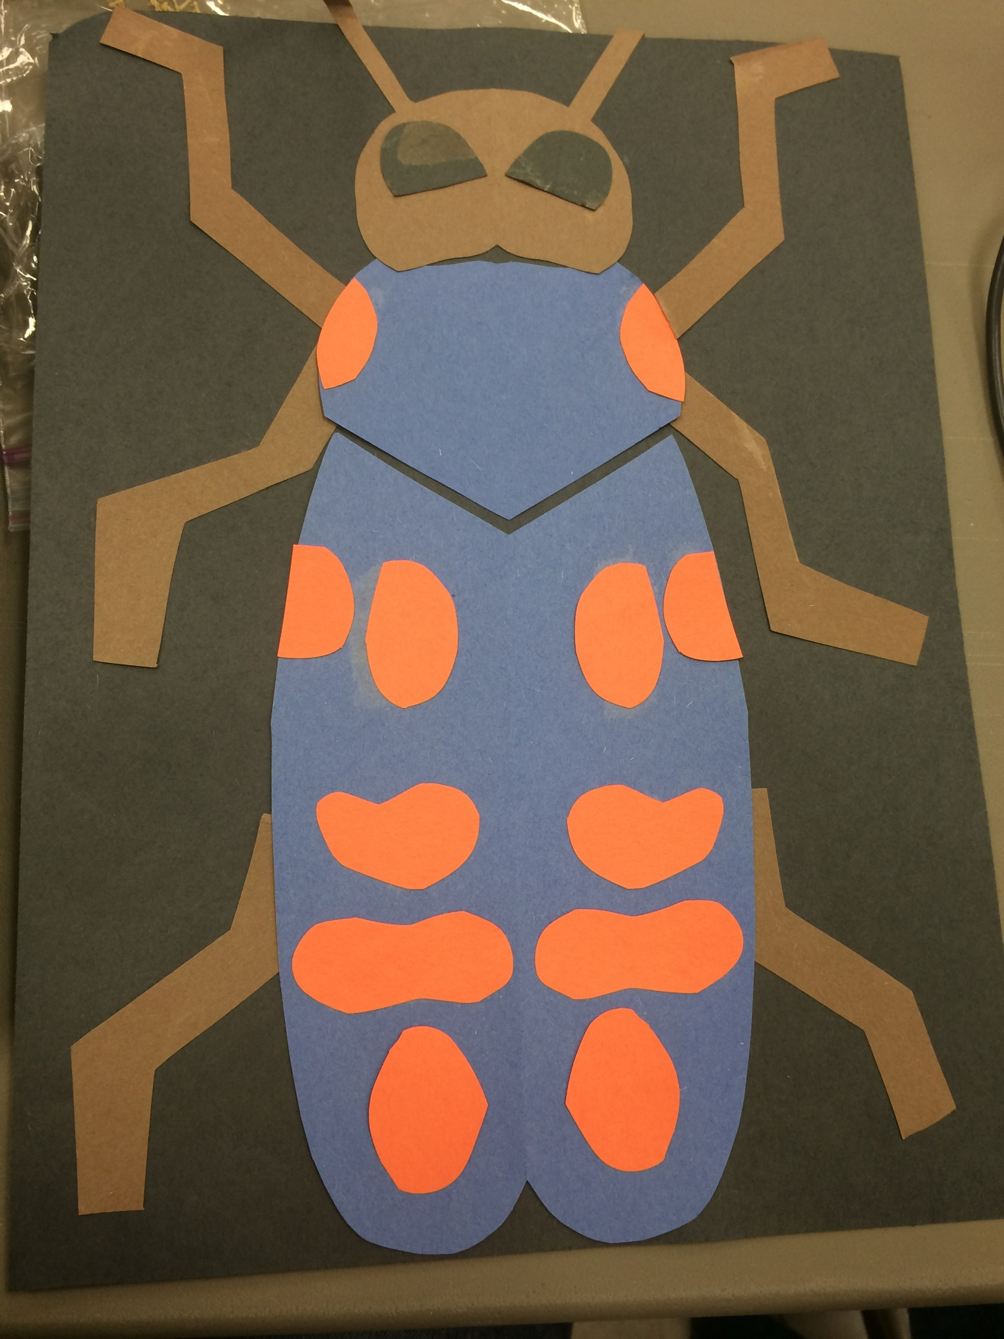
Name___________________Lesson______________________
Assessment
Thumbs Down | Don’t Know | Thumbs Up | Assessment Question
 |  |  | Did you use your personal best during this lesson?
 |  |  | Did you actively listen and follow directions?
 |  |  | Did you use your creativity? (is it original?)
 |  |  | Did you complete your project?
 |  |  | Did you incorporate the art media?
 |  |  | Does the artwork show the elements and/or principles discussed?
Source

