**BPS Elementary Art Curriculum**

Lines

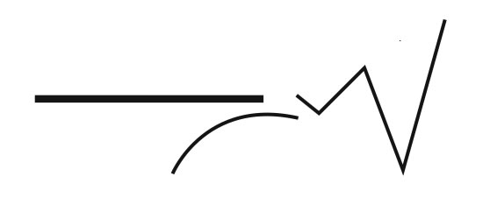

Content Connections:

Science – Life Cycle of a bug

Math - Symmetry

Art Standards: 4.1.5

Alignment Standards:

2.2.1

2.1.2

2.1.6

Materials:

Colored crayons

Water color paints and paint brushes

Pencil

Various Bug Books

Cups with water

|  |  |
| --- | --- |
| **Art Elements** | **Art Principles** |
| __Line | __Pattern |
| X Shape/Form | __Rhythm/movement |
| X Color | X Proportion/Scale |
| __Value | X Balance |
| __Texture | __Unity |
| X Space/Perspective | __Emphasis |

Grade: 2

Time: 1 + hours

Lesson

1. Research bugs – kinds, shapes, sizes
2. Discuss how bug bodies are symmetrical in nature
3. Share pictures from internet and classroom books showing this
4. Demonstrate how to draw bugs talking about balance on the paper with bugs as well as bugs going off and on the paper. A large bug can be balance with two smaller bugs on opposite side of the page. Also talk about perspective of not putting on big bug in the center of the page. Use your space well – more does not mean better.
5. Hand out water color paper and distribute various bug books for guides on what bugs to draw.
6. Circulate as students are drawing. 5-6 larger bugs are better than 10-12 smaller. The bugs must be detailed.
7. After bugs are drawn with a pencil, individual parts are firmly traced with vibrant colored crayons using crayon colors to keep symmetry
8. Various water colors are then used to fill in the spaces that were traced with crayon - again keeping symmetry and using balance with color.
9. Light various water colors to fill and one water color used to fill all background.
10. Students are responsible to clean water as needed as well as wash cups and brushes when done. Make sure to teach students how to press water from brush tips after cleaning and store with tips up for drying.

Vocabulary: balance, space, perspective, symmetry, color

I Cans

I can create original art and express ideas

I can use the process of drawing and painting to create art

I can illustrate characteristics of design using balance and proportion

Teacher Background Knowledge:

Need to understand balance, symmetry, space/perspective, and how to use lines to draw bugs.

Name___________________Lesson______________________

*Assessment*

|  |  |  |  |
| --- | --- | --- | --- |
| **Thumbs Down** | **Don’t Know** | **Thumbs Up** | **Assessment Question** |
|  |  |  | Did you use your personal best during this lesson? |
|  |  |  | Did you actively listen and follow directions? |
|  |  |  | Did you use your creativity? (is it original?) |
|  |  |  | Did you complete your project? |
|  |  |  | Did you incorporate the art media? |
|  |  |  | Does the artwork show the elements and/or principles discussed? |
|  |  |  |  |
|  |  |  |  |
|  |  |  |  |

Source