**BPS Elementary Art Curriculum**

Lines

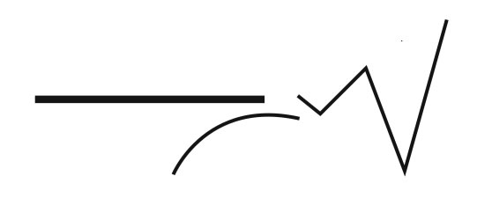

Content Connections:

Creating community learning about each other through a Name Art activity. (Beginning of year)

Art Standards: 2.2.1, 2.1.2, 2.1.6

Alignment Standards:

Materials: pencils, markers, 12x18 white construction paper, crayons, black sharpie, yard stick, colored pencils, thin black markers, copy paper

|  |  |
| --- | --- |
| **Art Elements** | **Art Principles** |
| _x_Line | _x_Pattern |
| __Shape/Form | __Rhythm/movement |
| _x_Color | __Proportion/Scale |
| __Value | __Balance |
| _x_Texture | __Unity |
| __Space/Perspective | __Emphasis |

Grade: 2

Time: 3 hours broken into 1 hour sessions

Preparation: 10 minutes

Vocabulary: medium, foreground, background, line pattern, focal point

I Cans

-use a variety of line in art work

-recognize and use organic shapes

-identify and use patterns

-create artwork using foreground and background

Lesson description:

Understand the specific art vocabulary and how to model it through an example.

Teacher Background Knowledge

Lesson

Day 1: Teacher shows how to make bubble/block letters on copy paper. Students then use pencil to draw their block name on 12x18 paper. Outline with sharpie. Have students make a focal point on letter. Draw five lines that go through the focal point. Outline the lines with sharpie.

Day2: Color name using markers. Each letter should be a different color. Then students take a pencil and create patters. Could use texture templates. Make a different pattern in each section. Trace the pattern in thin black sharpie or marker.

Day 3: Color patterns with color pencil or crayons.

Name___________________Lesson______________________

*Assessment*

|  |  |  |  |
| --- | --- | --- | --- |
| **Thumbs Down** | **Don’t Know** | **Thumbs Up** | **Assessment Question** |
|  |  |  | Did you use your personal best during this lesson? |
|  |  |  | Did you actively listen and follow directions? |
|  |  |  | Did you use your creativity? (is it original?) |
|  |  |  | Did you complete your project? |
|  |  |  | Did you incorporate the art media? |
|  |  |  | Does the artwork show the elements and/or principles discussed? |
|  |  |  |  |
|  |  |  |  |
|  |  |  |  |

Source