BPS Elementary Art Curriculum

Lines
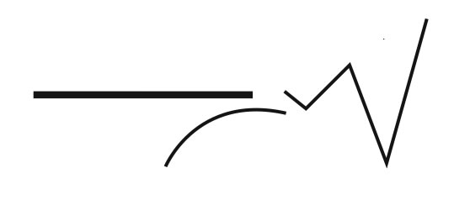
Materials:
Watercolor paper 11X 14, watercolor paints, brushes, cups for water, pencil (optional), black sharpies and 11X12 white construction paper

water
Content Connections:
Math
Reading
Science
Art Standards: 2.1.2, 2.1.6, 2.2.1, 2.3.1
Alignment Standards:
Bismarck Public Schools
North Dakota State Standards

Art Elements | Art Principles
X__Line | _X_Pattern
_X_Shape/Form | __Rhythm/movement
_X_Color | _X_Proportion/Scale
__Value | __Balance
__Texture | __Unity
__Space/Perspective | __Emphasis

Grade: 2nd
Time: Three sessions
Preparation:
You will need watercolor paper, watercolor paints, silver paint, brushes, and cups for water, pencils and black sharpies.

Vocabulary: brush techniques, shapes, lines, proportion, line, pattern, color, simple drawing

I Cans
1 I can explain the job of a robot.
2. I can create a robot using a simple line drawing.
2. I can create a pattern using colors and shapes.

Lesson description: Students will combine simple drawing and painting techniques to create an original work of art. They will explore patterns using different shapes and/or colors.
Teacher Background Knowledge
Knowledge of line, different brush techniques, shapes and use of color and patterns
Lesson
- Read the story Pearl and Wagner in our reading series.
- Discuss jobs that robots can do and what they think robots may look like.
- Show students simple drawings of robots and have them practice drawing their own robot in their notebooks.
- Give each student an 11x14 piece of white construction paper to draw their robot on. Remind students to think BIG when drawing their robot.
- Outline the robot with black sharpie, reminding them to go over all their pencil marks.
- Students then paint their robots with silver paint and let dry.
- The next day show students how to create a pattern with shapes and colors. Have a brief conversation about the color wheel and warm/cool colors. For this project we focused on using a pattern of cool colors and rectangles.
- Give each student a large sheet of watercolor paper, watercolor paints, brush and cup of water.
- Demonstrate how to make rectangle shapes with their paint brushes.
- Students paint a pattern of rectangles onto an 11X14 piece of white watercolor paper. They can choose to fill the space or leave open spaces between their rectangles. Let dry.
- The next day, cut robot out and glue on top of the watercolor pattern that was created.
Name___________________Lesson______________________
Assessment
Thumbs Down | Don’t Know | Thumbs Up | Assessment Question
 |  |  | Did you do your personal best during this lesson?
 |  |  | Did you actively listen and follow directions?
 |  |  | Did you use your creativity? (is it original?)
 |  |  | Did you complete your project?
 |  |  | Did you incorporate the art media?
 |  |  | Does the artwork show the elements and/or principles discussed?
Source
2012 Arts for Life
Watercolor Pattern Robots

